Supplemental Stories for pesach 5780
15 - 22 Nissan 5780/ April 9-16, 2020
Printed L’illuy nishmas Nechama bas R’ Noach, a”h

For a free subscription, please forward your request to keren18@juno.com

Kaifeng Jewish Community Suffers New Suppression
By Wang Yichi

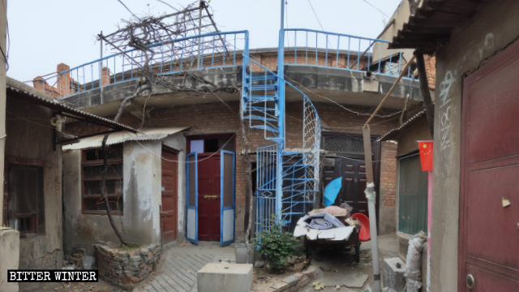
The site of Kaifeng Synagogue located in South Jiaojing Hutong

Under the pretext of “religious infiltration,” the CCP’s crackdown against religious groups has hit again the oldest community of Jews in the country.
by Wang Yichi
Since Xi Jinping took power, the repression of religion has been increasingly vigorous. Religious movements that are non-officially approved or considered to be influenced by foreign forces have been subjected to the government’s heavy crackdown. Even small religious groups like the tiny community of Kaifeng Jews are deemed as threats and thus persecuted by the CCP.

An ephemeral revival
The Kaifeng Synagogue, or what was later indicated as “the Site of Kaifeng Synagogue,” located in South Jiaojing Hutong, Shunhe district of Kaifeng city in the central province of Henan, is the last synagogue in the area. Its fascinating and complicated story has been previously told in Bitter Winter.

Signs on the doors and windows at the Site of Kaifeng Synagogue were removed.

The destruction of the Site of Kaifeng Synagogue
Judaism has witnessed a gradual revival in Kaifeng since the 1990s. A woman of Jewish descent in Kaifeng told Bitter Winter that more than 30 years ago, a young Israelite had come over to teach Hebrew and traditional etiquette to the Kaifeng Jews, who had later started to gather to attend worship services, chant the Torah in Hebrew, and circumcise their children ever since.
The number of attendees ranged from 40 to more than 80. Their religious activities were tolerated at the beginning, but suppressed after 2015 by the authorities, fearing they would lead to a reawakening of the Jewish faith. Traditional Jewish festivals such as Passover and Sukkot were prohibited. All Hebrew signs were removed.
In 2019, the regime once again targeted the Site of Kaifeng Synagogue on the ground that Judaism was not among the “Five Authorized Religions” that are controlled by the CCP. In April, personnel from the local community forced their way into the Site of Kaifeng Synagogue, and removed all Jewish signs such as signs mentioning that this was indeed the Site of Kaifeng Synagogue and flag of Israel from the doors and windows.
Instead, signs promoting the government’s attacks and repression against religion were hanging everywhere in the site. Among them there was an eye-catching sign that reads “Management of religious affairs should be in accordance with the principle of protecting the lawful and banning the unlawful, boycotting the infiltration and fighting the crime.”

Signs promoting the government’s attacks and repression against religion hung in the Site of the Kaifeng Synagogue

The Site of Kaifeng Synagogue under surveillance
The Jewish community in Kaifeng is the most well-documented Jewish community in China, and the oldest Jewish cultural site in East Asia as well. It has always drawn the attention of the visiting tourists and scholars from Europe, which increasingly disturbed the Communist regime.
To restrict the growth of Judaism, the CCP has set up layers of obstacles to prevent international organizations and foreign visitors from having contacts with the Kaifeng Jews. In the summer of 2019, the government rented a house next to the Site of Kaifeng Synagogue and converted it into “a “Community Comprehensive Cultural Service Center.” From Monday to Sunday, personnel assigned by the government are installed there, taking turns to closely monitor the activities in the site and the movements of the passers-by. A surveillance camera was installed at the entrance to the Synagogue.
“The surveillance camera was intentionally installed out there to monitor foreigners. Basically, [the authorities are] afraid of foreign infiltration, and thus want to stop foreigners from coming here,” a resident in the neighborhood told Bitter Winter.
One day in April, several students from Henan University came to the Site of Kaifeng Synagogue. They wanted to interview some Jews for their homework of a news report. As soon as the personnel of the community office learned the news, they hurriedly rushed to the Synagogue and drove those young people out.

The “Community Comprehensive Cultural Service Center” next to the Site of Kaifeng Synagogue

“In the past, many experts and professors from Israel, as well as people from all over the world, came here to have a look. And the street was always crowded with foreigners. Even the personnel from the community office led visitors here, but now coming here has become dangerous,” a woman of Jewish descent said sadly.

Historical site forced to vanish
All signs and sites connected to the history of Jews in the city are being eliminated. The woman added that there had been an old well drilled by Jews near the Site of Kaifeng Synagogue a thousand years ago, which was later listed as a “unit of special protection” by the Kaifeng Cultural Relics Bureau. In the spring of 2018, under the instruction from the government, the Kaifeng Cultural Relics Bureau dug out the stele bearing the words “Unit of Cultural Relics Protection,” and the old well was also buried and sealed in.
“I still vividly remember that the stele with a base was dug out, leaving a pit there. We used to stand there to sprinkle salt and offer prayers. But now hollies have been planted on it, and no trace remains,” she said.

Reprinted from the January 1, 2020 edition of Bitter Winter, a Magazine on religious liberty and human rights in China..

City of Fear: The
Fallout of Monsey
By Debra Nussbaum Cohen

Where once there was confidence and ease in being a New York City Jew — whether you were a Seinfeldian Upper West Sider or more a Brooklyn Chasid tucked into the comfort of a tightly knit community — now, there is fear.
After weeks of assaults, including 10 separate attacks over the eight days of Hanukkah, Jews of every denomination in the New York area are grieving, stunned by the violence and deeply shaken. People who are identifiably Jewish, especially those wearing the distinctive garb of Chasidim, feel especially vulnerable.
“The rate and severity of these attacks is not random. It feels like an explosive expression of anti-Semitism,” said Yocheved Sidof, mother of five and executive director of Lamplighter’s Yeshiva, which she founded, in Crown Heights. There are 147 students in grades K-12.
“It feels surreal that walking from my home to work, I traverse three corners that have had violence in just the past couple of weeks,” she said. “For my young children to even know where those corners are and feel targeted, that feels inexcusable.”
Sidof said she has been flooded with calls from anxious parents since the Monsey attack. Lamplighter Yeshiva is in a predominantly black corner of Crown Heights, she said, and she is keenly aware of the narrative accepted by some local African Americans and Caribbean Americans that Jews are “the white oppressors associated with skyrocketing housing costs.”
School staff and parents have heard, “Get the f— out of here, Jews” from locals, but Sidof said, “Thank God there hasn’t been any violence.” The school has full-time security guards but is investigating ways to beef up safety precautions, Sidof said. She also is planning an event with black members of the local community at the playground next to Lamplighters.

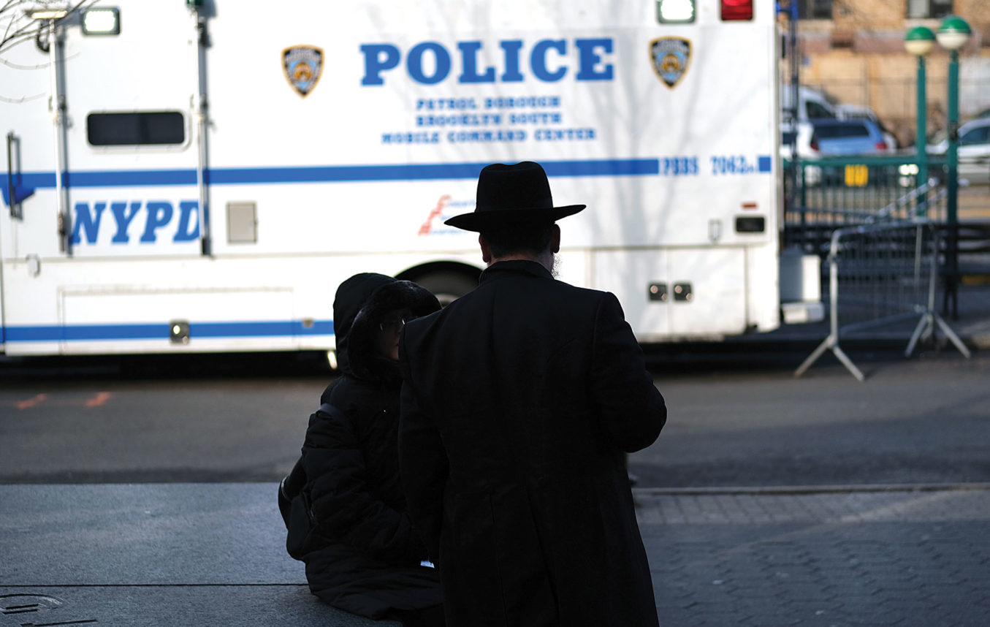
People walk through the Orthodox Jewish section of the Crown Heights neighborhood in Brooklyn on Dec. 31. Photo by Spencer Platt/Getty Images

About 1.5 million Jews live in New York City and there are some 2,000 Jewish institutions, including synagogues, schools and camps. Anti-Semitic incidents have seen a sharp increase in 2019 over 2018, up 63%, according to New York City statistics. The Anti-Defamation League (ADL) charts a smaller uptick from January through November 2019 over the same period in 2018. In figures provided to the Jewish Journal, the ADL measured it rising from 218 to 256 incidents of harassment, vandalism and assault in New York City.
The upward trend and severity of many of the attacks is traumatizing many.
Rivky Feiner has lived in Monsey all her 46 years. A consultant to nonprofits and mother of five children ranging in age from 8 to 26 years old, she never expected anything like the machete attack to happen in her quiet suburb. “It’s very frightening. How did he even know about the rabbi’s house? He might have seen visibly Chasidic people walking in and thought it was the shul. I just don’t know.”

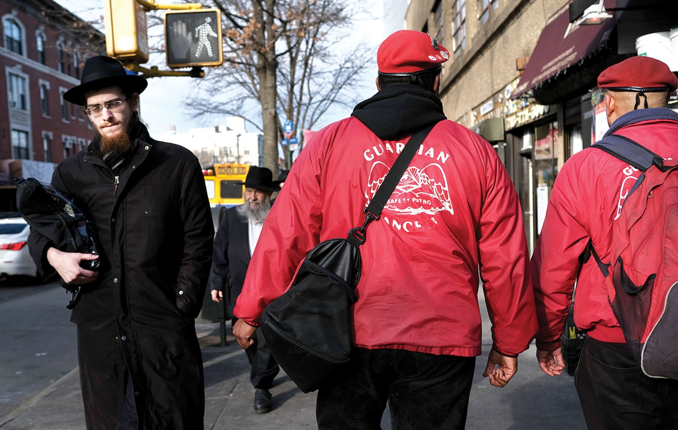
Members of the Guardian Angels patrol in Crown Heights, Brooklyn, on Dec. 31. Photo by Spencer Platt/Getty Images

She added, “We crossed a line” into new territory “and we can’t go back, so how do we move forward? My kids are frightened. How do we feel safe?”
About 1.5 million Jews live in New York City and there are some 2,000 Jewish institutions, including synagogues, schools and camps. Anti-Semitic incidents have seen a sharp increase in 2019 over 2018, up 63%, according to New York City statistics.
It also is reawakening the worst imaginable past traumas. An elderly Holocaust survivor in the area was at a meeting the day after the Monsey attack with Steve Gold, who is co-president of the Jewish Federation and Foundation of Rockland County, in which Monsey is located. “He said he was going home to pack his bag and have his passport out so that when they come for Jews here, he could escape,” Gold related.
“This wave of violence [against Jews] seems to be the worst, most sustained and lethal in the history of this country,” said David Myers, the Sady & Ludwig Kahn Chair in Jewish History at UCLA. “It is hard not to ask oneself, ‘Does the U.S. now join so many other places in the world as being unsafe for Jews?’ ”
A few days after the home invasion in suburban Monsey, the thoughts of many in the area are turning to larger approaches beyond increasing police patrols to try to interrupt this terrible pattern of daily attacks on Jews in the New York area. Some are calling for changes in laws; others for building bridges between the black and Jewish communities, where the relationship has grown increasingly tense. Others are demanding major initiatives by elected officials, some of which already had been announced at the many press conferences held in Rockland County and New York City in the first two days after the Monsey attack.
One major new effort announced on Dec. 30 by UJA-Federation — which does not cover Rockland County — and Jewish Community Relations Council (JCRC) of New York is a $4 million Community Security Initiative headed by expert security analyst Mitchell Silber. The money will fund Silber’s position and those of six security professionals who will be assigned to areas spread across the New York City region to assist Jewish institutions in strengthening their security. That $4 million nearly equals the JCRC’s entire 2017 budget, according to the most recent tax filing available.
Response from elected officials and leaders of various communities came swiftly after the Monsey attack whipped around the internet.

Black Leaders’ Responses
Rev. Al Sharpton — who has been widely disliked and distrusted in the Jewish community since he escalated tensions and disparaged Jews during the 1994 Crown Heights race riots — held a press conference on Dec. 30 surrounded by an array of black church leaders, the leader of the regional NAACP and elected officials, along with Rabbi Marc Schneier of the Foundation for Ethnic Understanding.
Sharpton alluded to the past troubles when he said at the press conference, “You cannot be anti-hate and pro-civil rights only one way. We rise particularly since the incidents involve blacks that have been arrested and charged, and say we condemn any attacks, any hate crimes, any efforts by anyone to impede the continuing move toward trying to heal whatever we have had to heal in the black and Jewish community.
“We are not unaware there have been tensions, but we have also been those who have strived to work those tensions out down through the years, and this will not set us back. We will stand with any move in our community to investigate hate crimes no matter who the hated and who the hater. We want to be crystal clear that we encourage members of our community to stand for what is right and righteous.”
Rev. Cornell Brooks was president and CEO of the NAACP through early 2017 and now is a professor at Harvard’s Kennedy School. In November, he called on America’s four living former presidents to issue a “national state of emergency on hate” and convene a national summit on hate and democracy.
In an interview, Brooks quickly cited Poway, Calif., where on April 27, a 19-year-old suspected of firing an automatic rifle killed one woman and injured three others at a Chabad synagogue, and the Tree of Life synagogue in Pittsburgh, where 11 Jews were killed during Shabbat services in October 2018. He also talked about “the recent uptick in and around New York” and asked, “How many Jews have to be attacked for us to realize we have a problem morally?”
Brooks said the approach to hate crimes must change nationally and on every government level. “We see a standardized response — talk retrospectively, prosecution at the back end without policy on the front end. It’s one thing for the NYPD (New York Police Department) to quickly respond. It’s another to prevent the perpetrator in the first place and to have a White House that speaks to these issues.”

Elected Officials’ Responses
New York state Attorney General Letitia James was among the first elected officials to weigh in on the horror in Monsey. “I am deeply disturbed by the situation unfolding in Monsey, New York, tonight,” she tweeted the night of the attack. “There is [zero] tolerance for any acts of hate of any kind and we will continue to monitor this horrific situation. I stand with the Jewish community tonight and every night,” posted James, who is black.
New York Gov. Andrew Cuomo called the Monsey attack “an act of domestic terror.”
Four Jewish New York state and city lawmakers representing heavily Orthodox areas issued a letter on Dec. 29 calling on Cuomo to institute a state of emergency and employ state police and the New York National Guard to “visibly patrol and protect” Orthodox Jewish communities. They also asked Cuomo to appoint a special prosecutor to investigate and prosecute perpetrators of anti-Semitic violence, and that the special prosecutor “immediately assume control of cases already under the jurisdiction of local district attorneys.”
“It is no longer safe to be identifiably Orthodox in the State of New York. We cannot shop, walk down a street, send our children to school or even worship in peace,” wrote New York State Sen. Simcha Felder, State Assemblyman Simcha Eichenstein and New York City Council members Chaim Deutsch and Kalman Yeger.
Just after the Monsey attack, Deutsch tweeted, “Can Jews walk down the street without being attacked? Can Jews shop for groceries without being attacked? Can Jews pray without being attacked? Can Jews ride the subway without being attacked? No — we can’t. We are sick of words. We need concrete action!!!”
On Dec. 29, New York City Mayor Bill de Blasio announced what he is billing as a “major new effort” to address hate crime in New York City: dramatically increased police patrols in ultra-Orthodox areas and multi-ethnic interfaith Neighborhood Safety Coalitions in Williamsburg, Crown Heights and Borough Park to bring together community leaders. He also announced a major educational initiative in public middle and high schools in those neighborhoods. It appears, from the city’s description, that it will entail discussion with public school students of hate crimes and how to prevent them, and bringing in members of the Jewish community to talk with them.
The red-bereted, red-jacketed Guardian Angels also deployed its unarmed patrols throughout those same three Chasidic Brooklyn neighborhoods on Dec. 30, promising to keep up its crime-deterring presence.

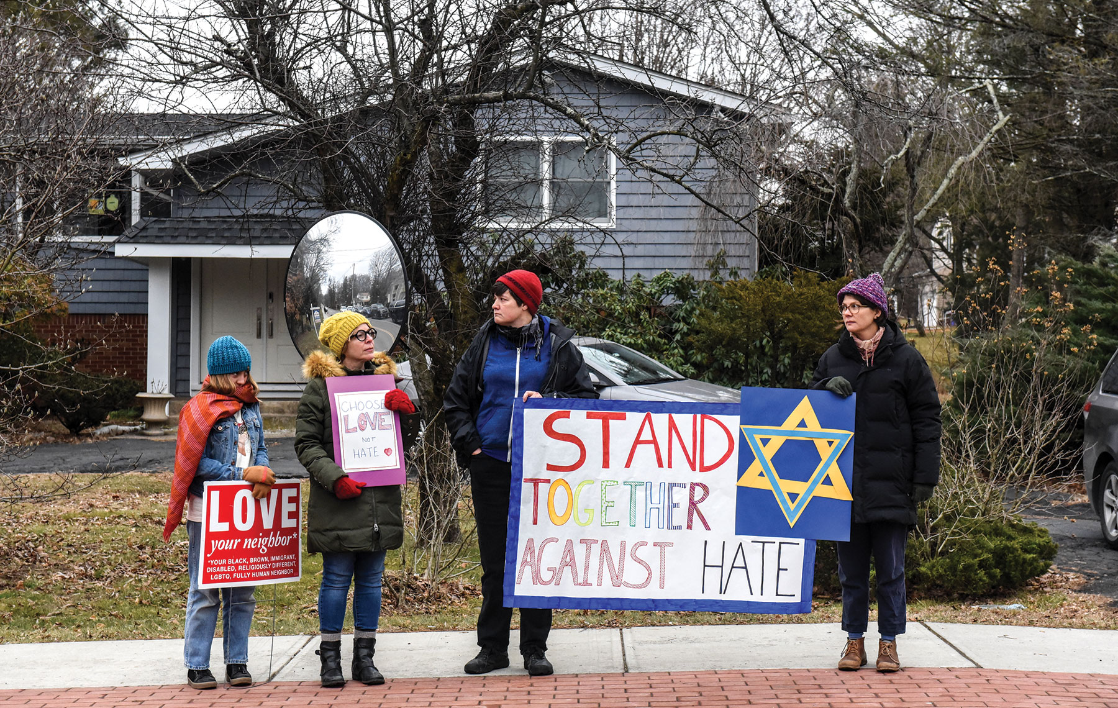Community members gather outside in Monsey. Photo by Getty Images

Jewish Leaders’ Responses
Just about every Jewish group issued a statement or offered interviews after the Monsey attack, which seemed to mark a tipping point in public outcry about the violence against Jews. Threaded throughout all of them was a sense of anxiety — and demands that elected officials strengthen hate crime laws.
Sheila Katz, CEO of the 90,000-member National Council of Jewish Women, grew up in Rockland County not far from Monsey, in a Reform-affiliated home in nearby Suffern. “Jews being attacked in their homes, walking to synagogue, in their supermarkets. Hanukkah is a time of celebrating freedom from persecution and instead, we’re living in fear and mourning,” she told the Journal.

“This wave of violence [against Jews] seems to be the worst, most sustained and lethal in the history of this country,” said David Myers, the Sady & Ludwig Kahn Chair in Jewish History at UCLA. “It is hard not to ask oneself, ‘Does the U.S. now join so many other places in the world as being unsafe for Jews?’ “

She urged New York and federal legislators to expand hate crime laws. “We’d like to see the New York state hate crimes law — and the federal government, as the United States Commission on Civil Rights recommended in its November 2019 report — place a greater emphasis on collecting hate crime data. In addition, we’re advocating for the passage of the Jabara-Heyer NO HATE Act” in Congress, she said.
“By better tracking and reporting incidents of hate crimes nationwide — which these measures will work toward — we’ll be better positioned to prevent and address these horrific attacks against the Jewish community and all marginalized communities.”
While Katz lit her Hanukkah menorah in a more convenient place in her Washington, D.C., home most nights of the holiday, she said that after the Monsey attack, that changed. “I’m putting my menorah near the window to make sure we’re all being a light in the darkness and showing up as Jews, saying, ‘We’re here and going to continue to be proud of our identities and combat anti-Semitism.’ ”
Agudath Israel of America, which represents the interests of the ultra-Orthodox community, wrote in a statement: “We beseech those in government to do everything humanly possible to halt this cancer. Continue increased patrols; apprehend and prosecute criminals. Get them — and keep them — in jail, to the fullest extent allowed by law. Enhance security funding to our vulnerable structures; work with us to provide training, so those within can protect themselves when necessary.”
It concluded: “We pray to the Almighty for a recovery to those injured in last night’s attack. We also pray that He grants those in leadership the fortitude to boldly do what is right, and heal, or remove, this malignant hatred in our country.”
Allen Fagin, executive vice president of the Orthodox Union, told the Journal, “The most important thing is for us to stop the hand-wringing and rhetoric and focus on concrete action in the short and long run. To make communal institutions safer and to engage in really serious community and school education efforts so this disease of hatred of all types is brought to a halt. That is a long and drawn-out battle.
“Perpetrators of hate crimes need to be treated by the criminal justice system in a fundamentally different way. We need to have laws that characterize violent hate crime as domestic terrorism and deploy law enforcement and judicial and prosecutorial resources that are necessary with real significant penalty,” he said. “It is terrorism.”

“A virus depends on the environment, and the environment today is user-friendly to the virus, to anti-Semitism.”
— Abraham Foxman, director of the Center of the Study of Anti-Semitism, New York’s Museum of Jewish Heritage

All the arms of the Conservative movement together wrote: “We thank law enforcement for their hard work and call on them to redouble their efforts to provide protection. We urge political and civic leaders to speak louder still and to work together even more closely to stem this tide of hatred and to address any repetitive pattern emerging from these attacks and those of the past year in the New York area. We must not allow acts of anti-Semitism to become the new normal.”

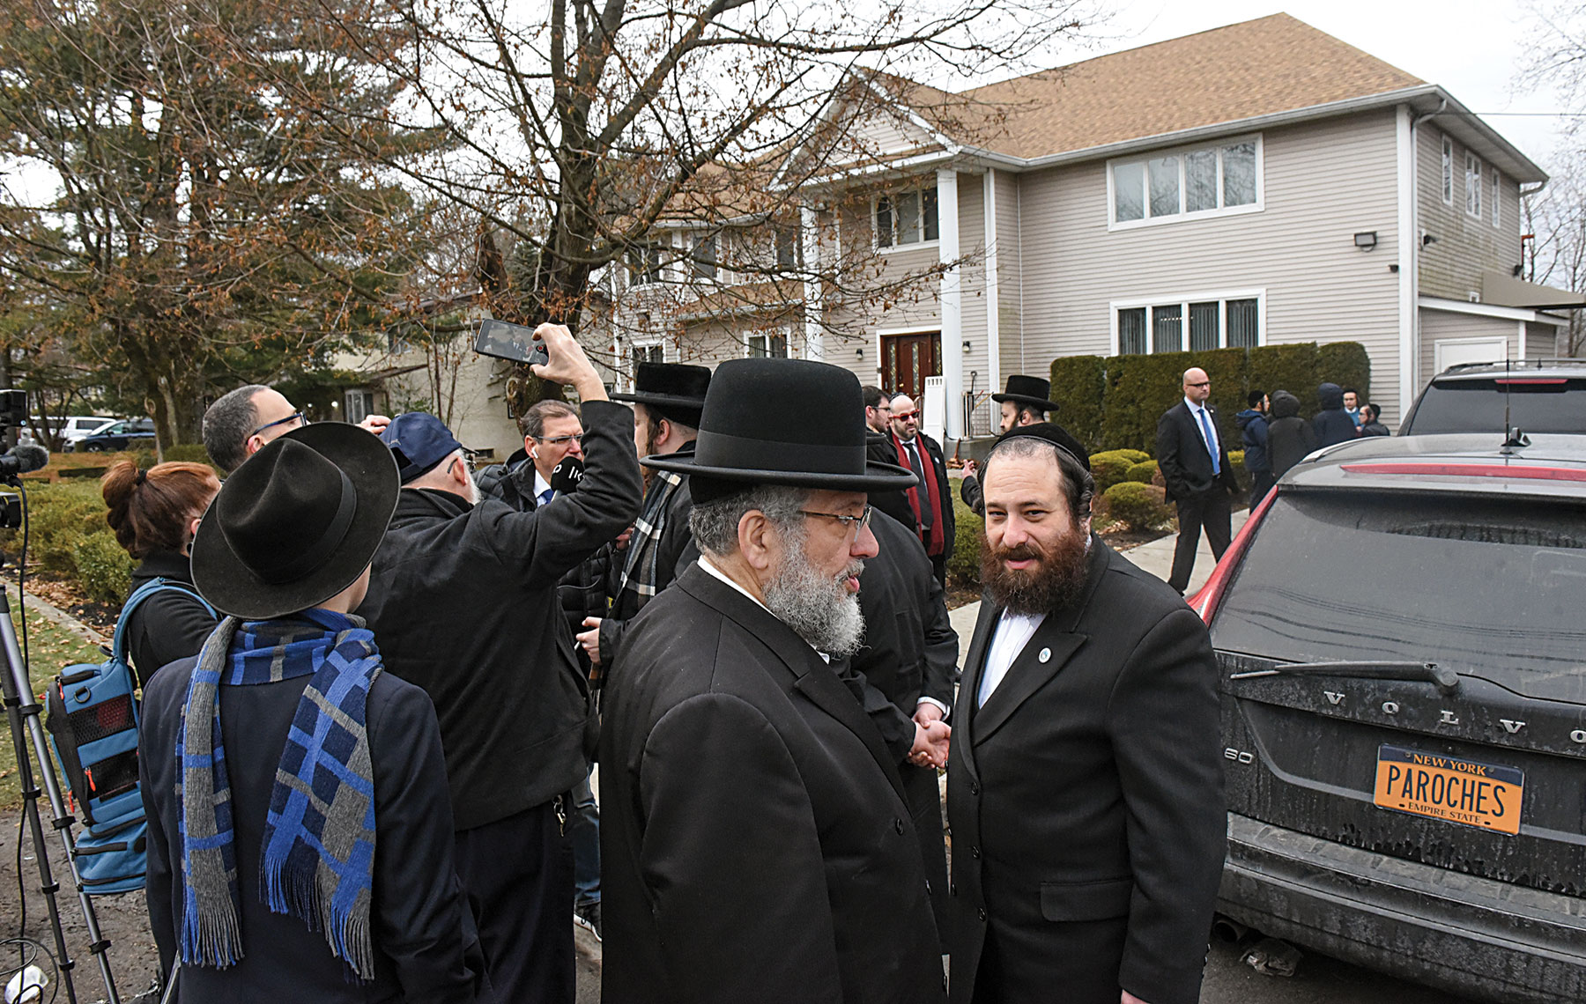Members of Rabbi Chaim Rottenberg’s community gather in front of the rabbi’s house on Dec. 29 in Monsey, N.Y. Photo by Stephanie Keith/Getty Images

Union for Reform Judaism President Rabbi Rick Jacobs tweeted soon after the Monsey attack, “We are outraged by the bloody machete attack in Monsey. We pray for the injured and call out for more protection. This week’s litany of anti-Semitic attacks on Jews in NY must be stopped. An attack on any of us is an attack on all of us!”

Others weighed in, as well.
“Antisemitism is not a threat to the Jewish community alone. It’s a danger to our democratic institutions and free society,” said Ira Forman in a statement. Forman is the senior adviser for Combatting Antisemitism at Human Rights First, a nonpartisan human rights advocacy organization. He previously served as the State Department’s Special Envoy to Monitor and Combat Anti-Semitism under President Bill Clinton.
“Confronting this rising epidemic is a task that requires bipartisan, long-term approaches at the federal, state and local levels. Confronting this scourge demands principled leadership from elected officials, thoughtful educational initiatives, evaluation of our justice system, and a commitment of resources to push back against hate.”

Ongoing Black-Jewish Tension
Nearly all of the attacks have taken place in communities where there has been ongoing tension between the black and Jewish — specifically Charedi — communities.
Monsey is near New Square and Kiryas Joel, villages devoted to the communities of Skver and Satmar Chasidim, respectively. No one else lives there. The East Ramapo School District, which covers those communities, controls the local public schools and the public funding that goes to the Chasidic communities for things such as special education and textbooks. Chasidim began voting other Chasidim onto the school board, quickly taking it over. They drained the budget, leaving little funding available for the public schools and leading to state government investigations and lawsuits — and a great deal of animus among the area residents, most of them black or Latino, whose children attend those schools.
In the view of Gold of the Rockland Jewish Federation, “There is absolutely a link between here and Ramapo,” he said. “The hate is out there in the open every day. In some Facebook groups, all they want to do is bash the ultra-Orthodox community. There was a comment today. Someone said, ‘The perpetrator didn’t stab enough of those Jews.’ ”

Missing Accountability
Anti-Semitism is “a virus without an antidote or vaccine and it’s always been present,” said Abraham Foxman, director of the Center of the Study of Anti-Semitism at New York’s Muse um of Jewish Heritage. Foxman led the ADL for 28 years, until 2015. “A virus depends on the environment, and the environment today is user-friendly to the virus, to anti-Semitism. The environment kept it latent. We, in the last 50 years in this country, developed a firewall, a social consensus of what is proper and improper and there were consequences for wrong behavior. Truth was a weapon. People were held accountable for their behavior.”
But that has changed. Foxman cited the recent example of a member of Jersey City’s Board of Education who, after the murderous attack on a kosher market in December, posted: “Where was all this faith and hope when black homeowners were threatened, intimidated, and harassed by I WANT TO BUY YOUR HOUSE brutes of the Jewish community?”
Many have called for the Board of Education to fire her, but Joan Terrell-Paige remains a trustee of the body. Foxman said, “She’s still on the job. So, where’s the accountability?”
Gold told the Journal that social media companies need to be held accountable, as well, because they provide environments where hate, at times, grows unchecked.

Just about every Jewish group issued a statement or offered interviews after the Monsey attack, which seemed to mark a tipping point in public outcry about the violence against Jews.

“There needs to be some responsibility by Facebook administrators,” Gold said, for what goes on in Facebook groups, like some focused on Rockland County and the Lakewood, N.J., area, where tensions between the ultra-Orthodox community there and other local residents is running high.
“They need to monitor these groups 24 hours a day. They say, ‘What do you want from us? We can’t monitor it.’ That’s B.S.,” Gold said. “The laws pertaining to regular media should pertain to social media.” Because of stereotypes, rumors and lies spread on social media, “no one knows what’s true anymore. Something needs to be done. There have to be some type of repercussions.”

Bail Reform Worries
New York state passed a new bail reform law that took effect Jan. 1. According to the Brennan Center for Justice, “It will eliminate pretrial detention and cash bail as an option in an estimated 90 percent of arrests.” There are exceptions to the new law in cases of domestic abuse, sex offenses, witness tampering and conspiracy to commit murder. But there appears to be none in connection with hate crimes.
Tiffany Harris, 30, was arrested and charged with attempted assault as a hate crime in the face slapping of three young Jewish women — in separate attacks — while yelling, “F— you, Jews!” on Dec. 27 in Crown Heights. She told police that she did it because they are Jewish, officials said. She was released without bail shortly after. A day later, she was arrested again, suspected of punching another person in the face. She again was released without bail because the charges were misdemeanors. Harris reportedly has been arrested 13 times in total, mostly for assault.
Fagin said New York state’s legislature needs to amend the law so those assaulting Jews in a hate crime don’t get away so easily. “The legislature knows how to draw distinctions. When it wanted to take sex offenders out from under the new law, they did it,” he noted. “We need to make the same distinction with hate crime.
“We simply cannot live as a society when those who commit hate crimes against any group are released and do it again the following day. We are turning our streets into a jungle,” he said.

Potential Retaliation
The Jewish security patrols known as the Shomrim in most Chasidic communities have vowed to beef up their presence in light of the recent violence.
There are others urging Orthodox Jews to arm themselves. A recent article from The Jewish Press is titled, “Experts Suggest 6 Firearms That Will Fit in Your Tallit Bag,” for purposes of concealed carry in synagogue.

“I completely broke down. I cried.” — Moshe Wigder, Jewish actor

There are videos like one titled, “Wild West, Monsey Style,” which shows four young Chasidic men toting what appear to be assault rifles as they saunter through a parking lot.
That attitude has one Monsey local very worried.
Moshe Wigder is an actor in one of the hottest off-Broadway shows in New York — the Yiddish “Fiddler on the Roof.” Raised Chasidic, mostly Satmar, he left Orthodoxy a while back but has lived in Monsey for about four years. Wigder was onstage in Manhattan when Grafton Thomas allegedly was swinging his machete, trying to murder Jews in his hometown.
Wigder already was deeply affected by the long string of attacks on Jews in New York and Jersey City. There is a scene in “Fiddler,” after the Jews have been expelled from Anatevka, in which his character, Mordkhe, enraged, talks to Tevye and says, “We can’t allow this! An eye for an eye, a tooth for a tooth!” Tevye puts his hands on Mordkhe’s shoulders and says, “Then the whole world will be without eyes or teeth.”
When he went offstage, checked Facebook and saw what had just happened in Monsey, Wigder said, “I completely broke down. I cried.”
The fear he knew as a Chasidic child with long side curls and a large yarmulke came flooding back. “I know that immediate fear. Whenever the goyim got drunk on Halloween or New Year’s Eve, we were afraid to walk in the streets, in Lakewood and in Brooklyn. They would throw things at us,” he recalled.
His anger, like Mordkhe’s, also has been awakened. Chasidim “happen to be the easiest targets because they’re a visual representation” of Jews, he said. “There has been a lot of tension with the black communities (in places he has lived) and that’s not helping anyone.” If the violence against Jews continues and it sparks any retaliation, “We’re going to have two minorities, then, without eyes or teeth.”

Debra Nussbaum Cohen is a journalist in New York City.

Reprinted from the January 2, 2020 edition of the Jewish Journal.

Historic Synagogue in Alexandria Set to be Reopened Following Major Renovation
By Adam Rasgon

Eliyahu Hanavi shul is one of two remaining Jewish houses of worship in the coastal city, where only a few Jews live today; Jewish leaders originally from Egypt welcome move
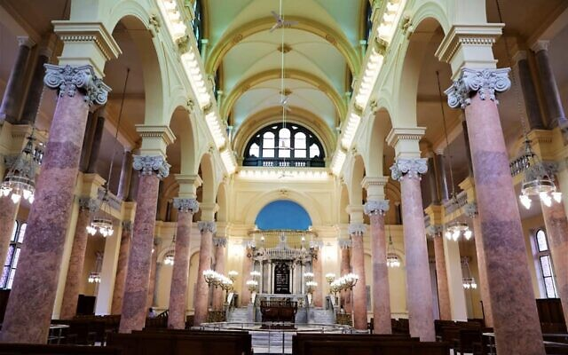
The Eliyahu Hanavi synagogue. (Egyptian Antiquities Ministry)

A major project to renovate the largest synagogue in the coastal city of Alexandria has been completed, Egyptian authorities announced over the weekend.
Eliyahu Hanavi, one of two remaining synagogues in the Egyptian city, will be formally reopened in January, Egypt’s antiquities ministry said in a statement on its Facebook page on Friday.
The house of worship is one of several Jewish sites in Alexandria, which was once home to an estimated 30,000-40,000 Jews. Its current structure was erected in the 1850s, after the original building, which dates back to the 1300s, was badly damaged in the late 18th century, during a French invasion of Egypt. It can hold approximately 700 worshipers.

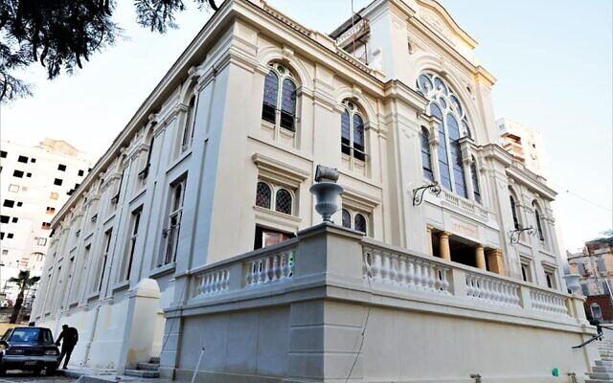
The Eliyahu Hanavi synagogue on December 20, 2019. (Egyptian Antiquities Ministry)

The renovations included the structural reinforcement of the synagogue, the restoration of its main facade, decorative walls, and brass and wooden objects, as well as the development of its security and lighting systems, the antiquities ministry statement said.
Eliyahu Hanavi was once an “active and bustling” synagogue, but it fell into a precarious state after rain water started to leak through its roof into the women’s section seven to eight years ago, said Alec Nacamuli, a former resident of Alexandria and a board member of the Nebi Daniel Association, an organization that works to preserve Jewish sites in Egypt.

“Then, four or five years ago, part of its roof collapsed and it was in urgent need of repair,” Nacamuli, who left Alexandria with his family for Europe in 1956 at the age of 13, said in a phone call. “The Antiquities Ministry stepped in to take charge of its restoration.”
The renovations cost approximately $4 million, paid by the Egyptian government, Nacamuli said, adding that Egypt turned down an offer by the Nebi Daniel Association to raise funds.

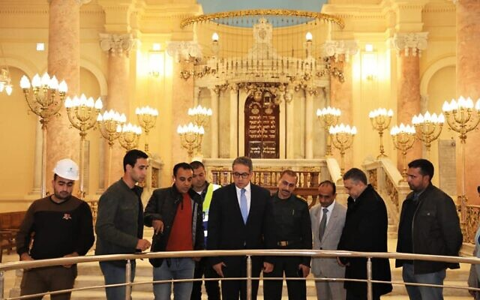
Egyptian Antiquities Minister Khaled al-Anani touring the Eliyahu Hanavi synagogue on December 20, 2019. (Egyptian Antiquities Ministry)

Egypt’s Jewish community, which dates back millennia, numbered around 80,000 in the 1940s, but today stands at fewer than 20 people. The departure of Egypt’s Jews was fueled by rising nationalist sentiment during the Arab-Israeli wars, harassment, and some direct expulsions by former Egyptian president Gamal Abdel Nasser.
Egypt and Israel signed a landmark peace treaty in 1979 and have since maintained formal diplomatic relations. But public opinion in Egypt has largely remained hostile to the Jewish state.
Only four or five septuagenarian and octogenarian Jews currently reside in Alexandria, Nacamuli said. The city used to house 12 synagogues, but most of them were sold over the years to support the Jewish community there, and its infrastructure and institutions, he said.
Egyptian Antiquities Minister Khaled al-Anani visited the Eliyahu Hanavi synagogue last Friday, the ministry said in its statement.
The Egyptian government maintains an interest in preserving Egypt’s antiquities –“whether they are Pharonic, Jewish, Coptic, or Islamic,” the statement said.

The Eliyahu Hanavi synagogue. (Egyptian Antiquities Ministry)

Egypt also sponsored the restoration of the Maimonides synagogue in Cairo in the 2000s.
But many Jewish houses of worship in Cairo, as well as a major Jewish cemetery there, have sat in disarray for decades.
Egyptian President Abdel Fattah el-Sissi said in November 2018: “If we have Jews, we will build [synagogues] for them.” In recent years, Sissi, who has led a widespread crackdown on dissent and jailed thousands of critics, has frequently met with Jewish delegations in the US and Cairo.
The Israeli Foreign Ministry indicated that it welcomes Egypt’s restoration of the synagogue.
“We take a very positive view of Egypt’s efforts to preserve the sites of the Jewish community that has existed in Egypt for more than 2,000 years,” spokesman Lior Haiat said in a text message, without explicitly referring to Eliyahu Hanavi.
Israeli Ambassador to Egypt David Govrin visited the synagogue in September 2016.

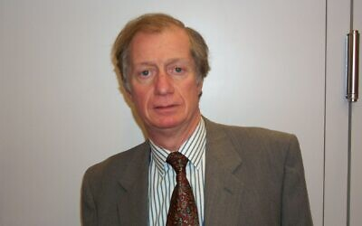
Alec Nacamuli, a former resident of Alexandria and
a board member of the Nebi Daniel Association.
(Courtesy of Alec Nacamuli)

On the day of his visit to Eliyahu Hanavi, he told the right-wing Arutz Sheva news site: “Restoring the synagogues is important because it’s part of our heritage, as well as part of Egypt’s history. It’s amazing and special to walk into an old, beautiful, magnificent synagogue. It’s a symbol of the past, of a time when there was a flourishing Jewish community in this city.”
In his comments, he also appeared to indicate that Israel could not financially support the restoration of synagogues in Egypt, “since that would seem to Egypt to be interfering, and Egypt does not want to be pressed into handing over documents or properties.”
Nacamuli, whose grandfather was an honorary president of Cairo’s Jewish community, praised Egypt for restoring Eliyahu Hanavi.
“I think this is an extremely positive move. It is recognition that Jews were part of Egyptian history,” he said, stating that Egyptian police protect all Jewish synagogues in the country.
Levana Zamir, the head of the International Association of Jews from Egypt, said that she was excited about the renovations to the synagogue.
“We are thrilled,” Zamir, who said she celebrated the Jewish new year at Eliyahu Hanavi with her family and diplomats in September, stated in a phone call. “This is grand piece of property.”
She added that she thought Egypt made the effort to restore the site for two major reasons.
“They did this work out of respect for antiquities and their Jewish past,” Zamir, who left Cairo with her family in 1949 at the age of 12, said, adding that the other factor was to encourage tourism.
Zamir, who now lives in Israel, said she and her family left Egypt after authorities arrested her uncle in 1948 and confiscated their property.
Nacamuli said that while it was unlikely a significant number of Jews would return to Egypt in the future, preserving the Jewish community in Egypt’s history was crucial.
“Will we ever see a resurgence of Jewish life in Egypt? I don’t know,” he said. “At least, there will be traces of our passage and history there. That is very significant.”
The Associated Press contributed to this article.

Reprinted from the December 23, 2019 website of the Times of Israel.

Cambodian Royal Family Celebrates Its First Bat Mitzvah
By Menachem Posner

The daughter of a princess who converted to Judaism comes of age

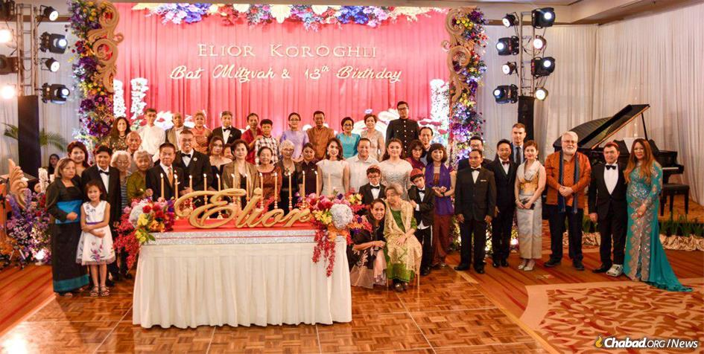
Cambodia's royal family turned out in Phnom Penh for Elior Koroghli's bat mitzvah party. She is standing in ninth from right, wearing a white dress, behind her younger brothers. (Photo: Kang Predi/Teh Ranie)

The giant menorah stood proudly overlooking the pool at the plush Raffles Hotel in the bustling heart of the capital city of Cambodia, Phnom Penh. Facing the crowd of well-wishers stood the who’s who of the royal family, guests from around the world and an Israeli-born Chabad rabbi.
They were there to celebrate the belated bat mitzvah of Elior Koroghli of Las Vegas. Her father, Ray (Rahamim), is a Persian Jew, and her mother Susie (Sarah Bracha) is the Washington, D.C.-born granddaughter of HM King Monivong, who ruled Cambodia until his death in 1941.
Elior’s bat mitzvah was the first Jewish milestone ever celebrated by the Cambodian royal family, and the first time many of the royals ever tasted food from a kosher kitchen, catered by Chabad of Cambodia, which was founded by Rabbi Bentzion and Mashie Butman in 2009.

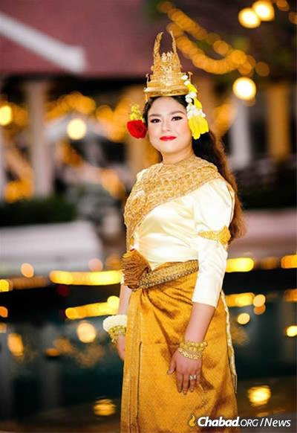
The bat mitzvah girl in traditional Cambodian dress. (Photo: Kang Predi/Teh Ranie)

The family celebrated the actual bat mitzvah in their home town of Las Vegas when Elior turned 12 on the fifth night of Chanukah a year ago, but the celebration in Cambodia took place this Chanukah, closer to her 13th birthday.
Literally a party for the books, the event will be chronicled in the Royal Palace Record Book.
The celebration was the brainchild of Susie Koroghli, who wanted her children, who live a full Jewish life in Las Vegas, to also know of their royal roots.
After the bat mitzvah party, highlighted by the kindling of a large menorah, speeches emphasizing the beauty and depth of Judaism and gratitude to G-d, and lots of kosher food, the family formally met the current ruler HM King Norodom Sihamoni and the queen mother, HM Norodom Monineath.

Elior's grandmother, center, is the daughter of King Monivong, who ruled Cambodia until his death in 1941. (Photo: Kang Predi/Teh Ranie)

The celebration continued on Shabbat at the Chabad House. When the entourage walked to and from the synagogue, they were escorted by an honor guard.
To cater for the event, Chabad invited Chef Kobi Mizrahi, who “took over” the kitchen and guided Chabad’s staff in creating meals that were truly “fit for a king.” In addition, some of the kosher food was prepared in the hotel kitchen under Susie’s watchful eye.

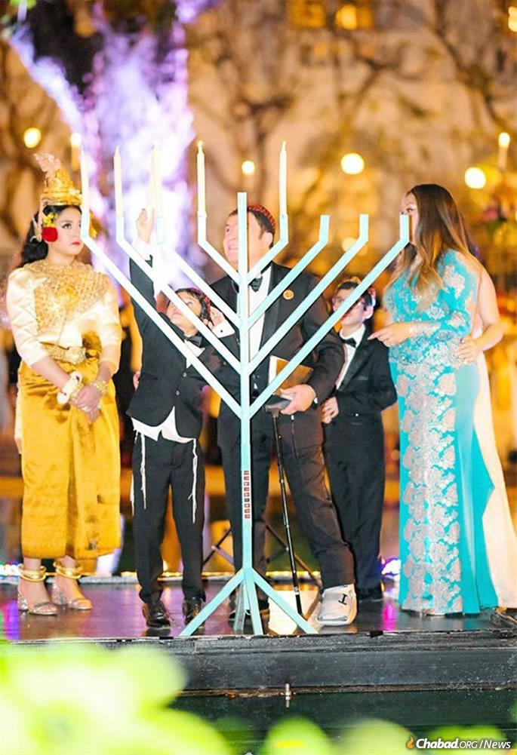
Elior with her parents, Ray and Susie Koroghli, and her
brothers at a Chanukah menorah-lighting during the
celebration. (Photo: Kang Predi/Teh Ranie)

No stranger to preparing meals for large crowds, she and her husband often host as many as 30 guests for a Shabbat meal and many more for Jewish holidays, including 120 that cram their giant sukkah and as many as 300 who attend the Purim party she throws every year.
“She lights up the room wherever she goes,” explains her husband with pride. “People are just drawn to her and are fascinated by her knowledge of Judaism, as well as her actions.”

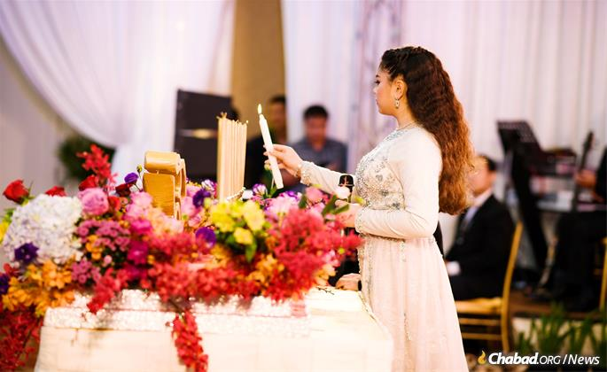
Elior’s bat mitzvah was the first Jewish milestone ever celebrated by the Cambodian royal family and the first time many of the royals ever tasted food from a kosher kitchen. (Photo: Kang Predi/Teh Ranie)

Susie Koroghli’s journey to Judaism is an unlikely one. Her father, Thay Sok, served as a Cambodian diplomat to the United States, and Susie (known as Sathsowi Thay in Cambodian) grew up in a Buddhist home.
She met Ray, who had left Iran to study in America and never returned home due to the 1979 revolution.

A Life-Transforming Class
Once, while waiting for Ray at Chabad of Southern Nevada in Las Vegas, she happened to hear a Torah class by Rabbi Shea Harlig. She was enthralled by what she encountered and insisted that they return. Thus began a journey of self-discovery that resulted in conversion to Judaism.
The couple lives with their three children in Las Vegas, where they form an integral part of the Chabad of Henderson community.

Elior's family are mainstays of the Las Vegas Jewish community. (Photo: Kang Predi/Teh Ranie)

Although she was a member of the royal family, raised with the formalities and expectations of a granddaughter of a king, she never visited Cambodia until 2012, when she represented her mother, HRH Sisowath Neary Bong Nga, at the funeral of late king HM Norodom Sihanouk.
It was only then, she says, that she realized that the stories she had been raised on were real—she was truly the child of royalty.
When asked if his wife, a leader in her Jewish community, was technically a Cambodian princess, Ray deflected, saying, “I call her my queen.”

Reprinted from the January 9, 2020 dispatch of Chabad.Org

Nagasaki and Holocaust Survivors: An
Unlikely Love Story
By Elliott Smith

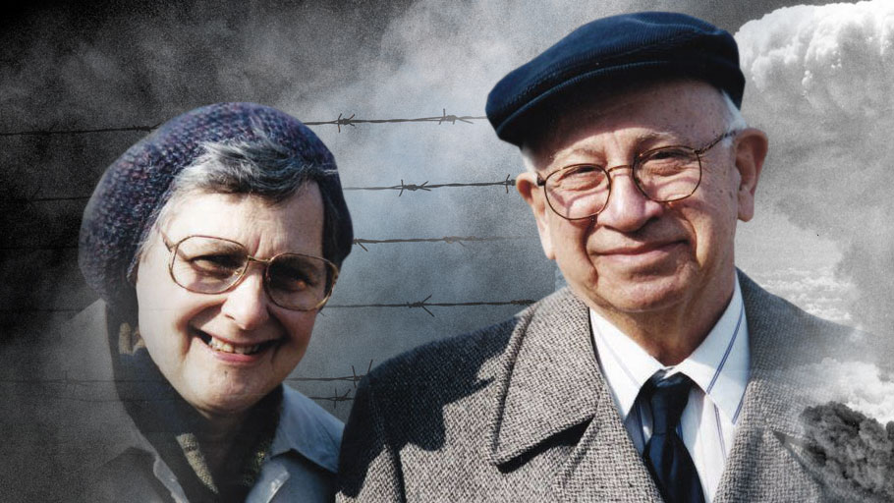
Through faith and courage, John and Sonja Franken’s love was meant to be.

John and Sonja Franken were two unlikely survivors of World War II. Sonja, a Dutch Jew from the Netherlands, survived the concentrations camps of Nazi Europe, including Auschwitz. She faced death in the gas chambers three times and miraculously survived. John, a Dutch-Indonesian Jew born in the former Dutch East Indies, was a prisoner of war in Japan and was working as a slave laborer in Nagasaki when the Americans dropped the atomic bomb there. He, too, survived.
They both suffered unimaginable cruelty on opposite sides of the world in the most extraordinary of circumstances and found everlasting love, against all odds. They would tell you it was bashert, meant to be.
Sonja was raised in a traditional Jewish home where the Sabbath, holidays and laws of the Torah were observed with the greatest joy, devotion and respect. Her father, Abraham, was a kosher butcher and her mother, Mietje, stayed home to raise the children and manage the household. Sonja said, “We were poor, but we were happy.”

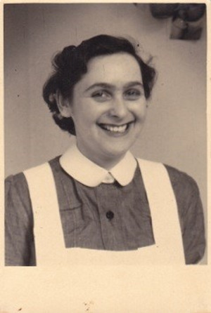
Sonja in her nurse uniform

That happy childhood was turned upside down at age 15 when she and her family were taken from their home by the Nazis to Camp Vught, a transit camp in the southern part of the Netherlands. This was the first of 11 concentration camps she endured.
Upon arrival at Vught, Sonja was forced apart from her parents, her two brothers and the eldest of her three sisters, not knowing where they were being taken to. Sadly, she was never to see them again. She found out after the war that they were all taken to Sobibor where they were immediately exterminated.

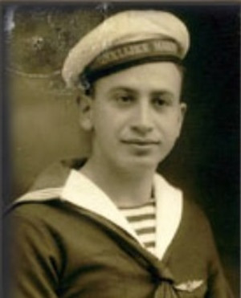
John in Dutch Navy uniform

Sonja and her two remaining sisters, Ro and Ali, were put to forced labor working in the radio assembly plant for Phillips Electronics. During her time in the camps, Sonja was quickly transformed from a shy, young girl into a bold and brave young woman when she risked her life to save the lives of identical twins who were destined for the evils of Dr. Mengele. She also saved her older sister’s life while on a death march through the mountains of Czechoslovakia in one of the coldest winters they’d had in over a hundred years. Unable to withstand the cold, starvation and exhaustion, her older sister Ro was ready to give up and die. Sonja would not allow it. She saved her sister’s life by pulling her sister onto her back and carrying her the rest of the way.
The war ended for Sonja in May 1945 when her camp was liberated by the Swedish Red Cross. She and her sisters were taken to Sweden where they recuperated for a year. Sonja then went back to the Netherlands where she worked in Amsterdam for a Jewish nursing home for the sick and elderly called the Joodse Invalide. Sonja longed to find her true love and have a family.
John was born on April 10, 1922, in the former Dutch East Indies, now known as Indonesia. His parents, Rosette and Leopold Franken, were Dutch Jews from Amsterdam who moved to the Dutch East Indies for a better quality of life as many Dutch people did at the time.
At 18, John was drafted into the Dutch Navy Air Force and while still in boot camp was captured by the Japanese to become a prisoner of War. He was first taken to a prison camp in Indonesia where he experienced torture and starvation and witnessed the murder of his fellow POW’s.
What haunted him the most into his old age was remembering the sounds of the cries for help from the young school girls who were kidnapped off the streets on their way to school and brought to prison camps where they were forced into sexual slavery. John remembered the terrible feeling of powerlessness, unable to help these innocent young girls who became known as the Comfort Girls.
John was taken to Nagasaki where he worked in the shipyards as a slave laborer. Three months before the end of the war, John transferred to work in the coalmines. As a result, he was hundreds of meters underground when the bomb fell on Nagasaki. It saved his life. He would tell you that it was bashert, meant to be.
After the war, John immigrated to Montreal Canada for a job as an aircraft mechanic with Canadair and lived the remainder of his life as a proud Canadian.
John and Sonja were introduced by correspondence through a mutual friend and fell in love by writing letters and exchanging photos between Montreal and Amsterdam. Their daughter, Roslyn, found all the love letters after Sonja passed away and translated them all into English. She includes excerpts from their beautiful love letters in her book, Meant to Be: A True Story of Might, Miracles and Triumph of the Human Spirit, that tells the unforgettable story about her parents.
In 1983 at age 56, Sonja was diagnosed with a very rare form of cancer. The doctors told her she should expect to live for only two more years. She told the surgeon, “You see this number on my arm from Auschwitz? Hitler didn’t get me, my cancer won’t get me. I have too much to live for.”
With that same fighting attitude that got her through the war, she defied every textbook case of her cancer her doctors had ever seen. She lived for another remarkable 21 years.
At 67, John suffered a massive heart attack and underwent quintuple bypass surgery. He was told that if he lived another 15 years he’d be doing well. He lived for another 27 years. When he passed away at 94 on June 15, 2016, he was recognized as the last Canadian POW Nagasaki atomic bomb survivor. Roslyn saw how they faced their life-threatening health issues with the same faith and fortitude that got them through the war.

At 29, Roslyn was diagnosed with Hodgkin’s Lymphoma with a tumor resting on the main artery to her brain. After the initial shock and fear, she turned to her parents’ “keep going and never give up” attitude as inspiration in her own fight to beat cancer and overcome many other obstacles in her life.
On October, 1995, Roslyn finished her last of 9 months of chemotherapy treatments and remains cancer-free. Today at 53 she enjoys a healthy, happy life. In looking back, she feels that her battle with cancer has given her a greater sense of inner strength, appreciation for life and continued drive to educate and inspire people toward a better life and a better world by sharing her family story of survival and triumph over tragedy.
Roslyn is committed to telling her family story to get people to reflect on the collective memory of one of the most horrific times in human history that must never be forgotten. She is reminding people about the dangers of discrimination, indifference and what this level of hatred and evil can lead to if we don’t do whatever we can to stop it.

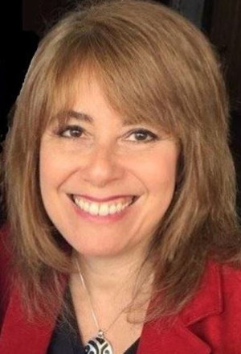
Roslyn Franken

And by telling people about her parents’ examples of strength, faith, appreciation and positive attitude toward life after witnessing and experiencing the worst of humanity, Roslyn is inspiring people toward a greater sense of hope, gratitude and courage to better their own lives and help make our world a better place.“My parents taught me that we all have a choice,” Roslyn says. “We can choose to be bitter or we can choose to be better. My parents chose to be better.”
Roslyn’s parents’ story was the subject of a Gemini award-nominated CBC television documentary and a feature-length movie adaption of Roslyn’s book, Meant to Be, is currently in development through Five Star Studios Inc. Roslyn travels worldwide telling her story to diverse audiences. For more information, www.RoslynFranken.com

Reprinted from the February 17, 2019 we
Judenrein Europe
By Joel Kotkin

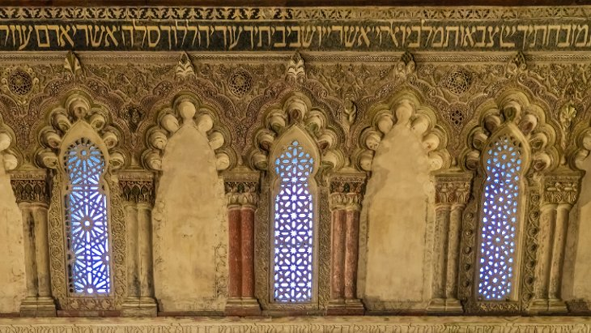
For millennia Europe was the center of diaspora life. But as Jews continue fleeing the continent, by the end of this century all that’s left will be a Jewish graveyard.

Last month the German commissioner for “Jewish Life in Germany and the Fight Against Antisemitism” used his impressively titled office to advise German Jews against wearing kipahs in public. The commissioner’s response to a surge of anti-Semitic violence in his country was a sheepish acknowledgment that Germany is once again a dangerous country for Jews.
And as Germany goes, so goes Europe. For millennia, following the destruction of the Second Temple and the beginning of the diaspora, Europe was home to the majority of the world’s Jews. That chapter of history is over. The continent is fast becoming a land of Jewish ghost towns and graveyards where the few remaining Jews must either accept an embattled existence or else are preparing to leave.
Some people go their whole lives without seeing a ghost; me, I see them all the time. – Detective Bernie Gunther in Phillip Kerr’s Greeks Bearing Gifts
In his earliest speeches Adolf Hitler made clear that his primary mission was to make Germany, and then all Europe, judenrein – free of Jews. He failed only because of the Allied victory but today, slowly, inexorably and, for the most part, legally and largely unconsciously, Europe is fulfilling the Nazi aspiration.
It is not only in Germany but in England, France, Hungary and elsewhere across the continent, that the many forms of European anti-Semitism – far right, left-wing anti-imperialist, and Islamist – are not only multiplying but moving closer toward controlling the official levers of power.

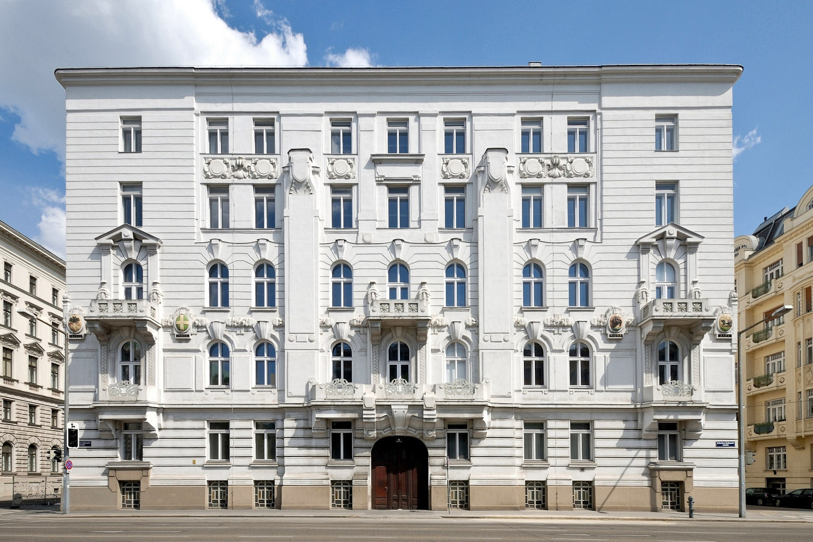
One of the famed apartment buildings in Vienna Ringstrasse, a grand circular boulevard that was once home to many wealthy Jewish families before WWII.

Progressives and Media Prefer to Blame
Anti-Semitism Primarily on the Deplorables
Progressives and the media prefer to blame anti-Semitism primarily on Europe’s deplorables, but the far right does not constitute the only, or even the primary threat, to European Jews. A detailed survey from the University of Oslo found that in Scandinavia, Germany, Britain, and France, most anti-Semitic violence comes from Muslims, including recent immigrants. Similarly a poll of European Jews found the majority of incidents of anti-Semitism came from either Muslims or from the left; barely 13% traced it to right-wingers. Violence against Jews is worst in places like the migrant dominated suburbs of Paris or Malmo in Sweden.

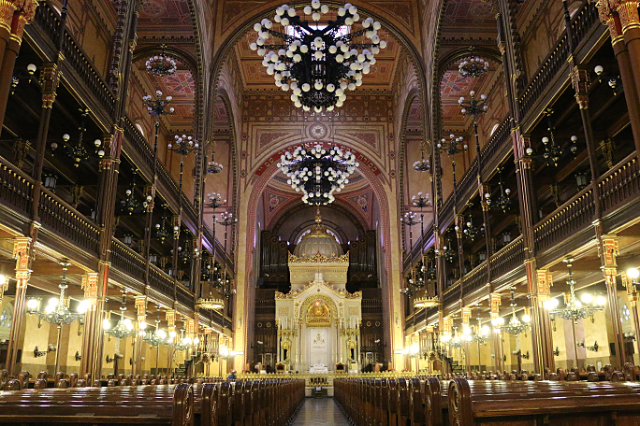
The interior of the Dohanny Street Synagogue in Budapest, Hungary built from 1854-1859 in the Moorish Revival style is the largest synagogue in Europe.

Nor is the hollowing out of Europe’s Jews confined to one region or type of country. The rate of exodus differs in Russia compared to France, and the sources of insecurity in Belgium are not identical to those in England. But, taken together, the phenomenon of Jewish flight crosses borders and applies to Eastern and Central Europe as well as the countries of the West.

Cities of Ghosts
In 1920 Europe was home to over half of world Jewry and many of its most creative, dynamic communities; today it contains barely 10% of the world’s Jews. The devastation wrought by the Holocaust is not, on its own, sufficient to explain this loss. In 1939 there were 9.5 million Jews living in Europe; at war’s end in 1945 only 3.8 million remained.
But today, more than half a century after the Holocaust, there are barely 1.5 million Jews left in Europe.
Cities once among the pearls of Jewish life – Vienna, Berlin, Warsaw, Lublin, Riga, Kiev, Prague – have Jewish populations that would fit neatly into a Texas suburb. Even the last great redoubts of Jewish life in Europe, Paris, and London, are threatened both by right-wing anti-Semitism, assimilation, and the pernicious new hybrid that joins leftist and Islamist hatred. Today Europe boasts only three of the world’s twenty most heavily Jewish cities – Moscow, London and Paris; the rest are all in the New World or Israel.
France, with the largest European Jewish population, has been sustained largely by the mass migration from North Africa. But it still has fewer Jews than it did in 1939 and seems destined to continue shrinking.
Eastern Europe, the center of the Jewish world in 1939 with its 8 million Jews, has less than 400,000 today. Germany, home to 500,000 Jews in 1933, now has as little as a third of that, with most originally refugees from Eastern Europe. Fewer than 15,000 of the Jews living in Germany today can trace their roots to the pre-Nazi era.

In Much of Europe the Artifices of Jewish
Life Has Been Reduced to Historical Relics
In much of Europe, the artifices of Jewish life are being reduced to historical relics. The great capital city of Vienna, chosen home of Sigmund Freud, Gustav Mahler, Theodore Herzl, and Billy Wilder as well as the birthplace of Arnold Schonberg, was home to over 200,000 Jews in 1923. Today there are barely 10,000 among Vienna’s 1.7 million residents, many of them refugees from the old Soviet bloc.
The early Hapsburgs, rulers of Central Europe’s last great empire, barely tolerated their Jewish subjects, treating them as “living fossils,” sometimes expelling them and other times allowing them a limited ghetto existence. But after their emancipation in 1867, noted historian Carl Schorske, Jews played an oversize role in the empire.
The city’s elegant Ringstrasse apartments were often both designed and inhabited by the Jewish upper crust. Some of these are now luxury hotels, catering to Vienna’s tourist trade. Former Hebrew Immigrant Aid Society official Walter Juraschek, a 60-something child of Eastern European refugees, estimates that out of the current population of Viennese Jews a mere 500 are native Austrians. Most of the rest come from outside the country: Orthodox and entrepreneurs from Israel, or the descendants of refugees from the east.
Austria Has Not Fully Confronted its Nazi Past
Austria has not fully confronted its Nazi past. The country, Juraschek suggests, still indulges the fanciful notion that it was “the first victim” of Nazism even though it largely welcomed the Anschluss, the unification with Hitler’s Germany, in 1938. Vienna incubated the anti-Semitism that so influenced Hitler, himself an Austrian, who lived there under the city’s famously anti-Jewish Mayor Karl Lueger. Adolf Eichmann, another native of the country, ran the Austrian Holocaust from the former Rothschild Palace on the elegant Prinz Eugen-Strasse.

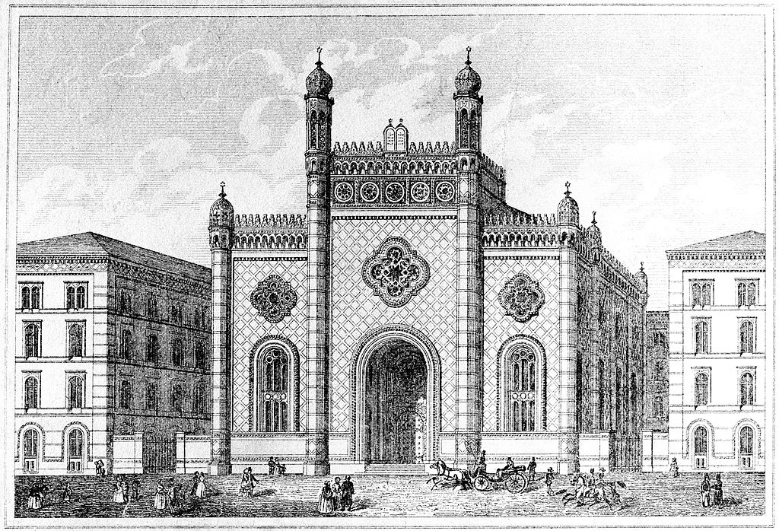
The exterior of the Leopoldstadter Temple in Vienna that was built in 1858 in the Moorish Revival style and destroyed by the Nazis on Kristallnach on Nov. 10, 1938.

“When I was growing up, Austrians never talked about this at all,” Juraschek recalls at a small Jewish coffeehouse not far from Judenplatz, the historic center of the city’s small Jewish community. “It only became public in the late ’80s when Kurt Waldheim [former U.N. secretary general and briefly Austria’s president] was unmasked as a former Nazi.” Nor have Austria’s far-right tendencies disappeared. Until last month, the Freedom Party, founded by former SS officers, functioned as part of the country’s conservative government.
Large Groups of Jewish Tourists Visiting
Vienna’s Restored Old Orthodox Temple
When my wife and I were staying in Vienna recently we saw large groups of Jewish tourists visiting the city’s restored old Orthodox temple, most of them visitors from North America and Israel. Such tours are now common through the old centers of Eastern and Central Europe, where visitors gaze at memorials to what were once the vital centers of Jewish communal life.
Like Vienna, many once great Jewish cities with communities numbering over 100,000 members – cities like Lodz, Kiev, Warsaw – only tiny residues remain. The chances of such vibrant Jewish communities coming back to life in these cities are as likely now as the actual blue and gray returning to American Civil War battlefields.
Like Vienna, Budapest once was a dynamic center of early 20th-century Jewish life. A boomtown – the fastest growing in fin de siècle Europe – it attracted Jews from throughout Eastern and Central Europe and became one of the most Jewish cities outside the czarist empire. In 1913, the Jewish community in Budapest exceeded 200,000 people, accounting for more than 20% of the city’s estimated 1 million residents. The city, scathingly labeled “Judapest” by Vienna’s Mayor Lueger, once boasted some 47 synagogues.

Most of Budapest’s Jewish Community Had
Lived in Highly Dense Urban Neighborhoods
Most of Budapest’s Jews lived in highly dense urban neighborhoods, but the upper crust, like their Viennese counterparts, lived in large apartments along streets like Andrassy Avenue. They thrived in part, notes historian John Lukacs, due to the dominant Magyar aristocracy’s relative inattention to business.
The magnificent Dohany Street Synagogue, third largest in the world after the Belz Great Synagogue in Jerusalem and New York’s Temple Emanuel, testifies to the vitality and great wealth of Budapest’s Jews. Its continued presence in the historic Jewish quarter of the city reflects the community’s complex history. Hungary’s Jews survived largely unscathed until 1944 due to the unwillingness of the country’s fascist dictator and Hitler ally, Admiral Miklos Horthy, to exterminate a population that, while discriminated against, still made significant contributions to the country’s productive economy. It was only in March 1944, when the Nazis installed more rabidly anti-Semitic elements inside Hungary, notably the fascist Arrow Cross, that the exterminations started.

Why the Dohany Street Synagogue Managed to Survive the Nazis
Even then, the Dohany Street Synagogue managed to survive, in large part because it served as Eichmann’s headquarters. The Nazi architect of mass slaughter cynically knew the Allies would be loath to bomb a building located amid the Jewish ghetto. The late date of the extermination campaign – and the intervention of brave gentiles like Swedish Count Raoul Wallenberg allowed many Hungarian Jews to survive the war – some 100,000 in Budapest alone.
Of the Jews who remained in Budapest after the war, many would leave following the failed 1956 uprising against the Soviets. Today demographic experts estimate that around 47,000 Jews are left in Hungary, although counts vary and some top 100,000. It’s a far cry from the past but more than a trace. There remain 17 synagogues in the city.

George Soros

This relatively robust Jewish community is located, ironically, in a country ruled by the autocrat Viktor Orban who has been widely criticized as fascistic and anti-Semitic. Orban has used thinly veiled anti-Semitic memes to attack his nemesis, George Soros.

Soros – A Devoted Atheist Who Has
Been Hostile to Both Israel and Jewish Life
But even some Orban critics, like blogger Ádám Szedlák, see his attacks on Soros – a devoted atheist who has often been cold, if not hostile, toward both Israel and Jewish communal life – as exercises not of anti-Jewish or proto-fascist ideology but of “political opportunism.”
Ironically, Orban is far more pro-Israel than European leaders widely celebrated as standard bearers of the liberal international order, like France’s Emmanuel Macron or Germany’s Angela Merkel. He is close to Prime Minister Netanyahu and maintains particularly strong ties to the Hasidic Jews of Budapest’s thriving Chabad community. Orban’s regime has also made Holocaust denial illegal, established an official Holocaust Remembrance Day, and refused to cooperate with the anti-Semitic, far right Jobbik party.
Some local Jews endorse Orban because his strongman nationalist approach has included a ban on Middle Eastern migrants into Hungary. Longtime Jewish activist Anni Fisher, the child of Holocaust survivors, dislikes Orban’s nativist rhetoric but argues that his immigration policies have prevented the virulent Islamism all too common in other European capitals from taking root in Budapest. “The Jews here live well, not bad,” she says. But even so, Fisher does not see much of a future for the community. “The young people are not staying. All we get are Israelis and the elderly who come here to retire.”

Budapest;s Jewish Quarter Remains Lively
Yet for now, in contrast to other European cities, Budapest’s Jewish quarter remains lively. You can find traditional Jewish food and klezmer music in popular hangouts like Café Spinoza. Some nominal Christians such as Kristof Molnar, a 32-year-old business development executive, are rediscovering the hidden Jewish heritage of their grandparents, and have participated in trips to Israel.

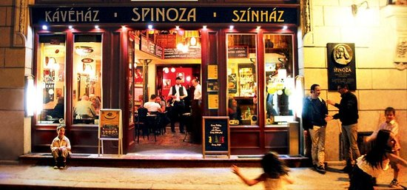
The Café Spinoza in Budapest’s Jewish Quarter

Although he sees no religious reawakening on the horizon, Molnar believes there is a modest restoration of the Jewish role in Hungarian life. “This is a new beginning,” he says. “It’s not like the old generation who only think of the Holocaust and memory. Among those of us in their 20s or 30s, there’s a desire to recommit to our own past and to that part of our Hungarian heritage that remains rooted in being Jewish.”

The New Threat in the West
In the past, the Jews of Hungary and other countries of Eastern Europe might have looked west for inspiration. Yet today the Jewish populations in Western Europe are themselves threatened and their populations seem likely to decline in the coming decades.
Some 90% of European Jews, according to recent surveys, have experienced anti-Semitic incidents.
The decline of Western European Jewry is caused by a confluence of factors. The least lethal threat lies in assimilation, which impacts roughly half of all European and American Jews. Assimilation has also been especially impactful on Russian Jews, the source of much recent Jewish migration to Western Europe, since as many as 70% lose their affiliation in adulthood.
But far more unnerving has been rising anti-Semitism. Some 90% of European Jews, according to recent surveys, have experienced anti-Semitic incidents. In France, anti-Semitic crimes were up by 74% in 2018 over the previous year.
Resurgent anti-Semitism in Europe has two faces, one familiar, the other of more recent vintage. A persistently weak economy, and the shrinkage of the middle class, have engendered, as in the last century, an explosive growth of right-wing populism across the continent. In some countries, notably Russia, Poland, Belgium and parts of Germany, anti-Semitism of the traditional right-wing type has been mainstreamed, often by nationalist parties such as the ADF in Germany, the Freedom Party in Austria and Jobbik in Hungary.
These forces include some who minimize the Holocaust. Alexander Gauland, one of the leaders of Germany’s AFD, called the Nazi Holocaust: “a speck of bird [manure] in 1,000 years of glorious German history.” Though Gauland’s rhetoric may appear shocking coming from a German public figure, it comports with a significant segment of the German public. Just over half of Germans now believe that Jews overplay the Holocaust, according to 2015 ADL survey, while a third blame Jews themselves for rising anti-Semitism.
But the far right, as famed Nazi-hunters Serge and Beate Klarsfield explained to my wife, Mandy, and me almost two decades ago, are not nearly as powerful a threat to Jews as the alliance of Islamists and left-wing activists. Increasingly the assault on Jews reflects a larger kulturkampf being waged against Western civilization; if Hitler saw the Jews as dangerous outsiders to European culture, the left today blames them for being too linked to continental values.
As in the 1930s, anti-Semitism is reaching beyond the marginal and into the educated mainstream. Sixty percent of German anti-Semitic messages came from well-educated people, according to one study. Today barely half of Europeans think Israel has a right to exist. The generally middle class Green parties, which emerged as big winners in Germany and across the continent after the recent European elections, tend to support the BDS movement, which aims to demonize and eliminate the Jewish State. The German Greens regularly label Israel as an “apartheid” regime.

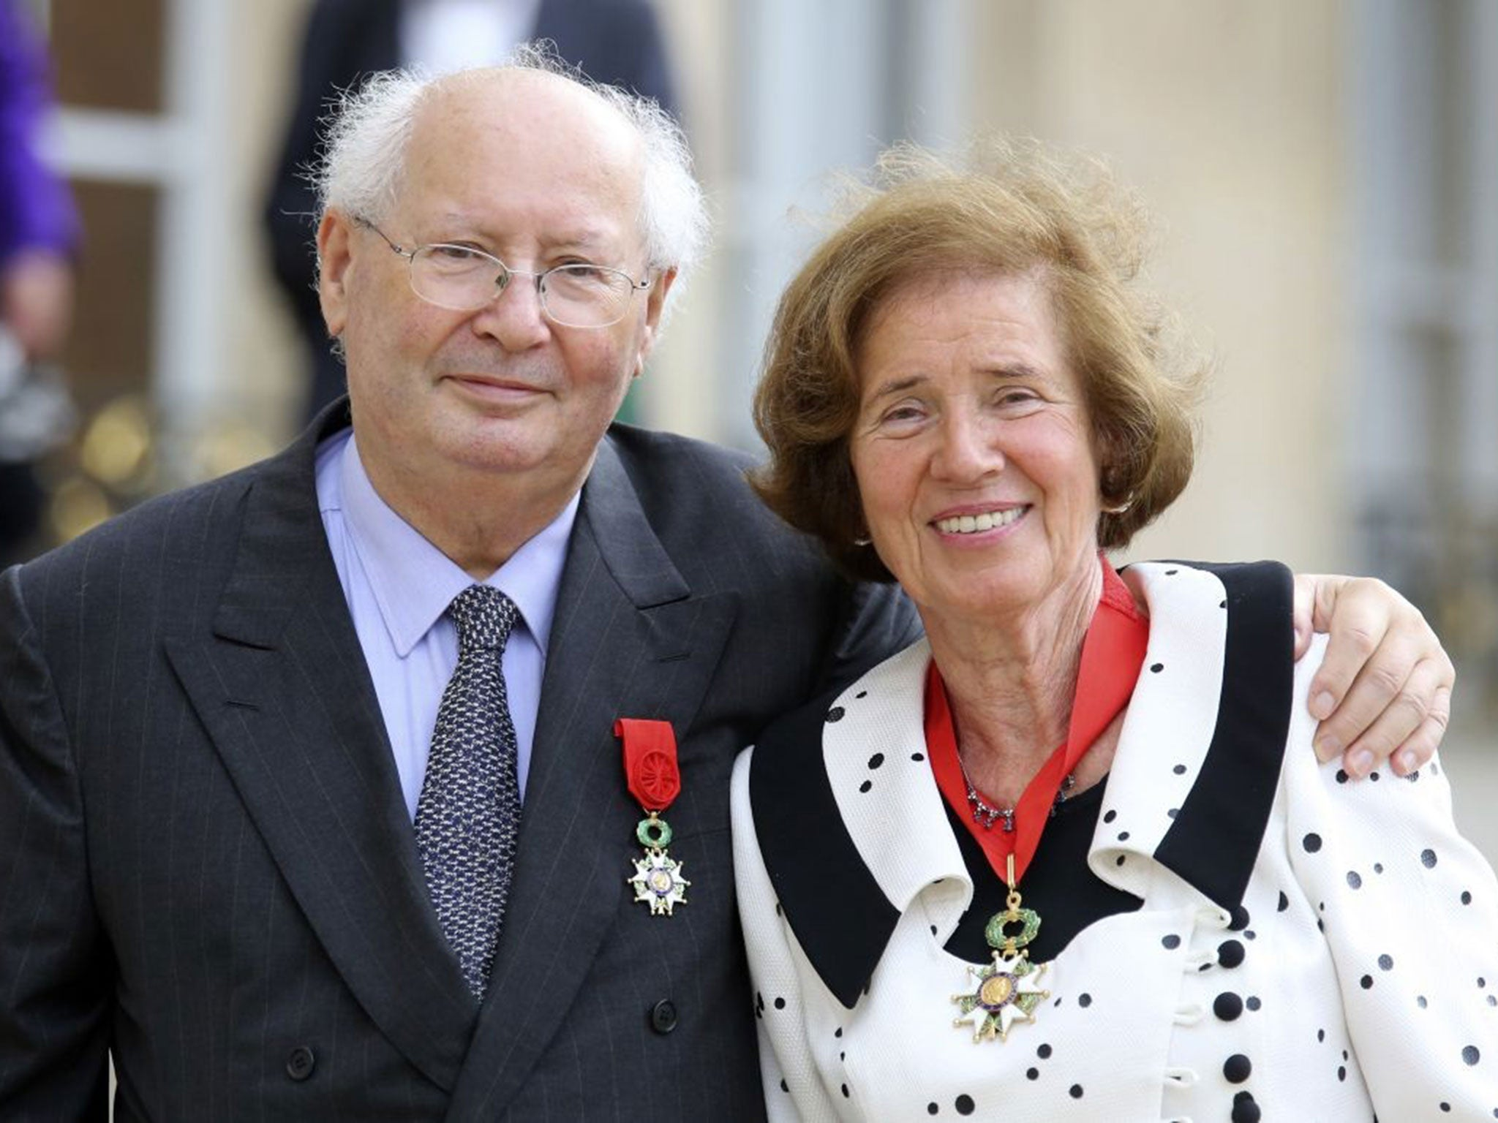
Famed Nazi-hunters Serge and Beate Klarsfield have been honored by both France and Germany and have devoted their lives to tracking Nazi mass murderers of Jews.

Jewry’s Post-European Future
Europe will not become completely judenrein in the near future. But the signs of decline are everywhere and the endpoint to which they lead appears inescapable. In Russia, the once huge Jewish population has fallen from 1.4 million in 1989 to roughly 400,000. The Israeli demographer Sergio della Pergola, an expert on Jewish populations across the world, recently pointed out that last year Russia witnessed 8,000 deaths of elderly Jews but only 600 births recorded to Jewish mothers.
The signs of decline are everywhere and the endpoint to which they lead appears inescapable.

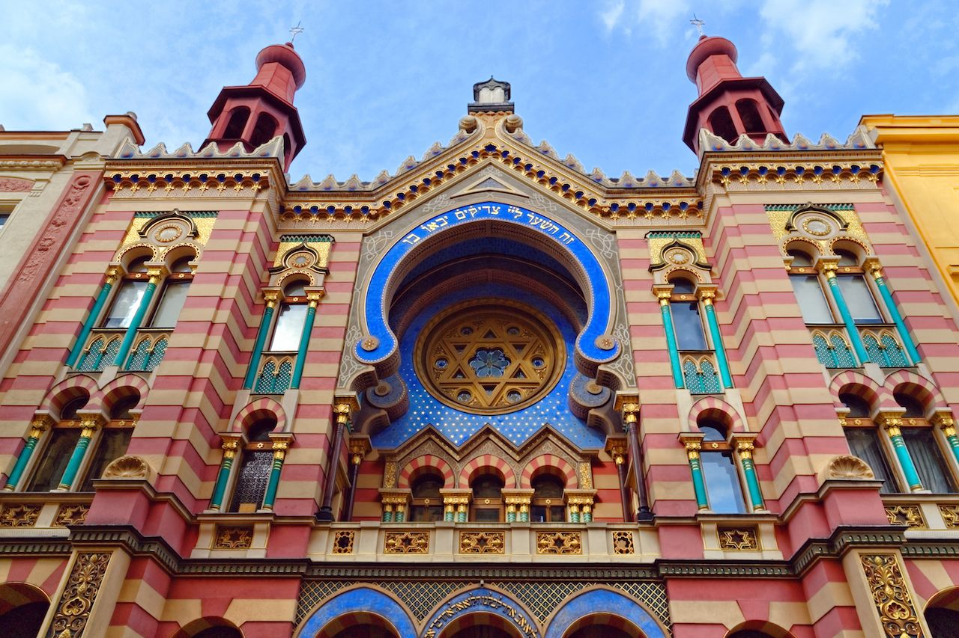
The Jubilee Synagogue in Prage, Czech Republic, was designed in 1906 and named after the Jubilee Anniversary of the reign of Emperor Franz Joseph I of Austria.

In Great Britain the Jewish population has declined over the past half century. The prospect of Labour Party leader Jeremy Corbyn, whose long history of anti-Israel and Judeophobe associations is well known, becoming the next prime minister constitutes what Britain’s former chief Rabbi Jonathan Sacks called, “an existential crisis.” If Corbynism maintains its hold on British politics it could spark a mass exodus of British Jews. By century’s end, one study predicts, what remains in England will be a largely Orthodox community constituting the majority of the country’s Jews.
France, today home to the world’s third-largest Jewish community, appears to be following the same pattern of demographic decline. Though the French Jewish community was temporarily revived by mass migration from its former North African colonies, it has since been battered by a rising Islamist threat and a steady increase of anti-Semitic attacks.
Since 2000 nearly 50,000 Jews have left France, mostly for Israel, the United States, and Canada. With no likely source of new immigration since the Middle East and North Africa are already largely judenrein, it’s difficult to envision how France’s Jewish population will grow in the future – the one exception to this being the Orthodox who can grow with above-average birth rates.
Taken together, the forces of history, politics, anti-Semitism and migratory patterns spell the likely demise of Judaism in Europe, particularly its more secular elements. The once widely spread tribe is rapidly concentrating in North America and Israel, together home to roughly 90% of all Jews.

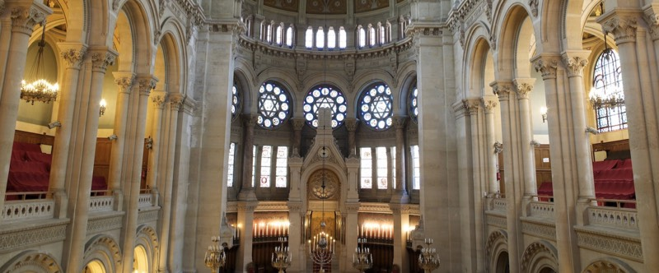
The interior view of the Grande Synagogue de Paris.

Yet even in America and Canada, both assimilation and resurgent anti-Semitism, not just among the far right, but in the universities and progressive political movements, including among Democratic members of Congress, may lead increasing numbers to feel they need to choose between their Jewish roots and their political commitments.
Over the long term, if current trends hold, the Jewish future could become predominantly Israeli, much as the French sociologist Georges Friedman predicted a half century ago. Beginning at the turn of the 20th century and continuing through recent decades, the Jewish population in North America grew by absorbing immigrants first from Central and Eastern Europe and later from places like the former Soviet Union, Iran, and North Africa.
Today over 70% of diaspora Jews live in the U.S. and Canada but the aggregate numbers may decline because these Jewish communities will no longer be able to count on the infusion of “new blood” to keep them vital.
With close to a majority of all Jewish children living there already, Israel in the near future will become, for the first time since early antiquity, the home to a majority of all Jews. It marks the end of an epoch of Jewish life, and the beginning, however fraught, of a new one.

Reprinted from the June 29, 2019 website of Aish.com This article originally appeared on Tabletmag.com Joel Kotkin is Presidential Fellow in Urban Futures at Chapman University in Orange , California and executive director of the Center for Opportunity Urbanism in Houston, Texas. Author of eight books, he writes regularly for the Orange County Register, the City Journal, and the Daily Beast.

Stranded in Nova Scotia, Rescued by Chabad
By Barry Schechter

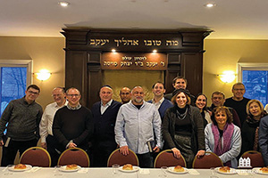

.

In Halifax, Barry Schechter with fellow El Al passengers in Halifax.

Editor’s note: When El Al’s flight 26 from Newark was diverted to Halifax, Nova Scotia, last Shabbat, East Brunswick’s Barry Schechter and his family were among the stranded passengers. Here, he writes of his emotional experience on Shabbat in a letter of thanks to his Chabad hosts.
Dear Rebbetzin Bassie and Rabbi Mendy Feldman,
On behalf of my family and everyone on El Al 26, I would like to thank you both for your incredibly gracious, generous and heartfelt hospitality in Halifax. I know I speak for all of us when I say we quite literally could not have made it through Shabbos without you.
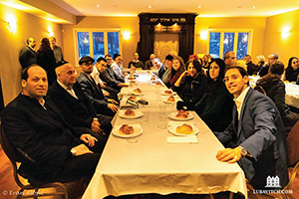
When we were told by the pilot of El Al 26 that our Newark to Tel Aviv nonstop would be making an actual stop due to mechanical difficulties, we were certainly taken aback. For many of us, Shabbat was the first worry as we landed in Halifax late Thursday night. We imagined davening in a hotel conference room at best and an airport lounge at worst.

In Halifax, Barry Schechter is seated with other passengers.

But once El Al told us that they had contacted Chabad, a cheer rose up from the plane.
Only later did we learn that in addition to preparing a large amount of food to accommodate the many passengers, and being instrumental in coordinating the generous shipment of meals (from very caring askanim in Montreal) delivered by wonderful yeshiva bachurim Yossi and Dovid, you also helped organize buses, hotels and many other details.
Friday night was emotional, to say the least. With students away vacation, we helped make a minyan in this smaller community, and the davening and zemirot were quite literally overwhelming.
As we sat down to eat a sumptuous meal, you and others gave beautiful divrei Torah that touched us all. When the El Al staff arrived to give us updates and their first concern was whether we had enough to eat, we knew that we were dealing with a Jewish airline. And when they said we were in good hands with

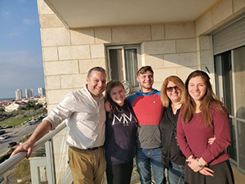
The Schechter family together in Modiin at the home of the Goldsteins, formerly of Edison.

My wife Allison and my daughter Dora agreed as we walked back that this was the definition of making lemons into lemonade.
Saturday morning was a more intimate affair as some of our group walked to the local Orthodox shul to help augment their minyan, and the rest of us went to Chabad. Then we all came together from both minyanim to eat another great meal.
Singing. Dancing. Divrei Torah. New friends. Stories. Young people schmoozing. Older folks schmoozing. And the biggest game of Jewish geography ever played!
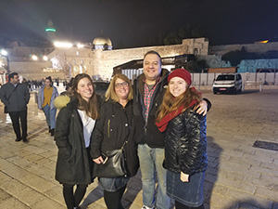

Allison and Barry Schechter on their first trip to Israel, with Dora, Max and Eden at the Kotel.

In fact, half of us figured out we went to school with/taught/were taught by/carpooled with/know/have cousins in common with/know a dentist who did our fourth cousin’s tooth extraction, etc. We bonded as a group and “adopted” wonderful young men traveling solo (Mark from Deal, Dan from Englewood, and Ari from Staten Island). They and Dora and Nicole from Englewood and Ariel from Englewood all formed a nice little chevra (in addition to helping set up and clean up, as we all did).
We davened Mincha and then we took our leave back to the wonderful Lord Nelson Hotel, whose staff could not have been better.
After a couple of hours of sightseeing in historic Halifax, we davened Maariv at the hotel, did an impromptu Havdalah, and immediately boarded our buses back to the airport.
I write to you as we are over the Adriatic Sea, according to the screen keeping me awake above my head. God willing, Allison and I will be seeing Eretz Yisrael for the first time as we visit our twins Max and Eden, who are learning at Lev HaTorah and Machon Maayan, respectively. (Dora is back after her year at MM).
We will be seeing family and friends, God willing, all over the country.
Of course, the irony of another Mr. Magoo moment for me does not escape those who know that the twins were born on September 11, 2001, which is why I was not at the World Trade Center that day.
Regards, and we hope to see you, as we hope to see all our new friends, in good times, in Canada, the U.S. or Israel, perhaps with the coming of Moshiach! Amen!
P.S. (sent a few days later): Here we are at the Kotel, our first visit there as a family. It was electrifying and, honestly, overwhelming. At Machon Maayan, I was asked to speak to the school about what happened. It was very emotional (and funny, now that it is days later; comedy is truly tragedy + time). And El Al 26 passengers (in our new “The Halifacts” WhatsApp group) have thanked me for the letter. Because they all feel the same way.

Reprinted from the January 16, 2020 website of the JewishLinkNJ.com

Why Are So Many Young People Unhappy? Part One
By Dennis Prager

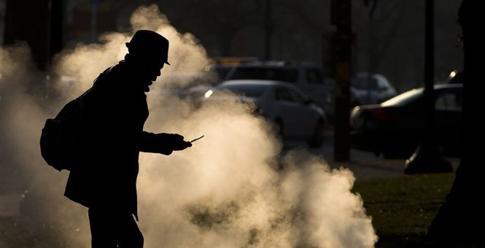

Here are some unhappy statistics:
— In America between 1946 and 2006, the suicide rate quadrupled for males ages 15 to 24 and doubled for females the same age.
— In 1950, the suicide rate per 100,000 Americans was 11.4. In 2017, it was 14.
— According to Grant Duwe, director of research and evaluation at the Minnesota Department of Corrections, in the 1980s, there were 32 mass public shootings (which he defines as incidents in which four or more people are killed publicly with guns within 24 hours). In the 1990s, there were 42. In the first decade of this century, there were 28. In all the 1950s, when there were fewer controls on guns, there was one. Fifty years before that, in the 1900s, there were none.
— Reuters Health reported in 2019, “Suicidal thinking, severe depression and rates of self-injury among U.S. college students more than doubled over less than a decade, a nationwide study suggests.” The study co-author Jean Twenge, a psychology professor at San Diego State University, said, “It suggests that something is seriously wrong in the lives of young people.”
This data is not only applicable to Americans. As social commentator Kay Hymowitz wrote in City Journal in 2019: “Loneliness, public-health experts tell us, is killing as many people as obesity and smoking. … Germans are lonely, the bon vivant French are lonely, and even the Scandinavians — the happiest people in the world, according to the UN’s World Happiness Report — are lonely, too. British prime minister Theresa May recently appointed a ‘Minister of Loneliness.’ … consider Japan, a country now in the throes of an epidemic of kodokushi, roughly translated as ‘lonely deaths.’ Local Japanese papers regularly publish stories about kinless elderly whose deaths go unnoticed until the telltale smell of maggot-eaten flesh alerts neighbors.”
Though people have more money, better health care, better health, better housing and more education, and live longer than at any time in history, they — especially young people — are unhappier than at any time since data collection began.
Why has this happened?
There are any number of reasons. Increased use of illicit drugs and prescription drug abuse, and less human interaction because of constant cellphone use are two widely offered, valid explanations. Less valid explanations include competition, grades anxiety, capitalism and income inequality. And then there are young people’s fears that because of global warming, they have a bleak, and perhaps no, future.
But the biggest reason may be the almost-complete loss of values and meaning over the last half-century.
Let’s begin with values.
America — and much of the rest of the West, but I will confine my discussion to America — was founded on two sets of values: Judeo-Christian and American. This combination created the freest, most opportunity-giving, most affluent country in world history. This is not chauvinism. It is fact. And it was regarded as such throughout the world. That is why France gave America — and only America — the Statue of Liberty. That’s why people from every country on Earth so wanted to immigrate to America — and still do.
Chief among American values was keeping government as small as possible. This enabled nongovernmental institutions — Kiwanis International, Rotary International and Lions Clubs International; book clubs; the Boy Scouts and Girl Scouts; bowling leagues; music societies; and, of course, churches — to provide Americans with friends and to provide the neediest Americans with help. But as government has gotten ever larger, many of these nongovernmental groups have dwindled in number or simply disappeared.
Another set of values is what is referred to as “middle-class” or “bourgeois” values. These include getting married before one has a child; making a family; getting a job so as to be self-sustaining and sustain one’s family; self-discipline; delayed gratification; and patriotism.
All of these have been under attack by America’s elites, with the following results:
One in 5 young Americans has no contact with his or her father (not including fathers who have died).
In 2011, 72% of black children were born to unmarried mothers. In 1965, it was 24%. In 2012, 29% of white children were born to unmarried women. In 1965, it was 3.1%.
The majority of births to millennials are to unmarried women. Yet, according to a 2018 Cigna study, single parents are generally the loneliest Americans.
Marriage and family are the single greatest sources of happiness for most people. Yet, the percentage of American adults who have never been married is at a historic high. More Americans than ever will not get married, or they will marry so late they will not have children. In 1960, 9% of blacks ages 25 and older had never been married. In 2012, it was nearly 40%.
And I haven’t even mentioned the biggest problem: the loss of meaning in young people’s lives. I will discuss that in part two.

Reprinted from the January 21, 2020 website of the Dennis Prager show. This column was originally posted on Townhall.com.

Why Are So Many Young People Unhappy? Part 2
By Dennis Prager

I began part one of "Why Are So Many Young People Unhappy?" with data showing the apparently unprecedentedly high rate of unhappiness among young people in America (and elsewhere, but I am focusing on America). The rates of suicide, self-injury, depression, mass shootings and loneliness (at all ages) are higher than ever recorded. It seems that Americans may have been happier, and certainly less lonely, during the Great Depression and World War II than today, even with today's unprecedentedly high levels of health, longevity, education and material well-being.

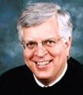
Dennis Prager

There is, of course, no single explanation, and I listed a number of possible explanations: "Increased use of illicit drugs and prescription drug abuse, and less human interaction because of constant cellphone use are two widely offered, valid explanations. Less valid explanations include competition, grades anxiety, capitalism and income inequality. And then there are young people's fears that because of global warming, they have a bleak, and perhaps no, future."
But I do believe that a loss of values and meaning are the two greatest sources of unhappiness.
Among the values lost are those of communal associations. As the great foreign observer of early American life Frenchman Alexis de Tocqueville wrote in 1831, Americans' unique strength derived largely from their participation in innumerable nongovernmental associations — professional, social, civil, political, artistic, philanthropic and, of course, religious.
But these have all dwindled as government has become ever larger. Whereas Americans got together and formed bonds of friendship through nongovernmental associations, through what organizations will Americans form friendships today? In a video presentation at its 2012 national convention, the Democratic Party offered its answer: "Government's the only thing that we all belong to," the narrator said.
Then there are traditional middle-class values, like getting married first and then having children. Today, a greater percentage of Americans are born to unwed mothers than ever before, and fewer people are marrying than ever before. There are, for the first time in our history, more single Americans than married Americans. While it is certainly possible to feel lonely in a marriage, people are far more likely to feel lonely without a spouse, and increasingly without children, than with a spouse and children.

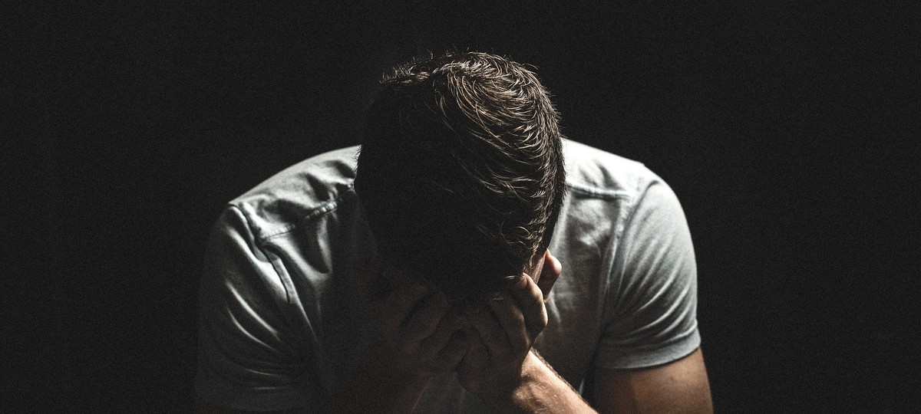

And now we come to the biggest problem of all: the lack of meaning.
Aside from food, the greatest human need is meaning. I owe this insight to Viktor Frankl and his classic work "Man's Search for Meaning," which I first read in high school and which influenced me more than any book other than the Bible. Karl Marx saw man as primarily motivated by economics; Sigmund Freud saw man as primarily driven by the sexual drive; Charles Darwin, or at least his followers, sees us as primarily driven by biology.
But Frankl was right.
As regards economics, poor people who have meaning can be happy, but wealthy people who lack meaning cannot be.
As regards sex, people who do not have a sexual life (such as priests, who keep their vow of chastity; many widowed and divorced older people; and others) but have meaning can be happy. Sexually active people who do not have meaning cannot be.
As regards biology, there is no evolutionary explanation for the need for meaning. Every creature except the human being does fine without meaning.
And nothing has given Americans — or any other people, for that matter — as much meaning as religion. But since World War II, God and religion have been relegated to the dustbin of history.

The result?
More than a third of Americans born after 1980 affiliate with no religion. This is unprecedented in American history; until this generation, the vast majority of Americans have been religious.
Maybe, just maybe, the death of religion — the greatest provider of meaning, while certainly not the only — is the single biggest factor in the increasing sadness and loneliness among Americans (and so many others). A 2016 study published in the American Medical Association JAMA Psychiatry journal found that American women who attended a religious service at least once a week were five times less likely to commit suicide. Common sense suggests the same is true of men.
The bottom line: The reason so many young people are depressed, unhappy and angry is the left has told them that God and Judeo-Christian religions are nonsense; their country is largely evil; their past is deplorable; and their future is hopeless.
That seems to be a major reason, if not the reason, for so much unhappiness: not capitalism, not inequality, not patriarchy, sexism, racism, homophobia or xenophobia but rather having no religion, no God, no spouse, no community, no country to believe in and, ultimately, no meaning. That explains much of the unprecedented unhappiness.
And it explains the widespread adoption of that secular substitute for traditional religion: leftism. But unlike Judaism and Christianity, leftism does not bring its adherents happiness.
JWR contributor Dennis Prager hosts a national daily radio show based in Los Angeles.

Reprinted from the January 28, 2020 email of Jewish World Review.
THE GREAT DEBATE:
Thanksgiving and Halacha
By Rabbi Yair Hoffman

Some call it the great MO versus Yeshivish Community Divide. However, the question has not yet entered the list of “Shidduch questions” that are generally posed to parents of children who have now entered the phase of dating. Is it halachically proper to formally celebrate Thanksgiving with a turkey dinner with one’s family?
This is not to say that the Yeshiva community does not express appreciation for the wonderful freedoms that this country has championed both for its citizens and for peoples throughout the world.
The greatest of our Rabbis have stated that the United States is a “malchus shel Chessed – a Kingdom of Lovingkindness” and that our thoughts and prayers should express appreciation for the wonderful nation in which we live. Indeed, one Rosh Yeshiva once stated, “I would rather be a street-sweeper in America where I have the religious freedom to learn Torah, than a Rabbi in Communist Russia.”

The Questions
The questions rather, however, are, is it permitted to express one’s appreciation within the context of following the rituals of the Thanksgiving holiday? We may further ask, what is the exact nature of the Thanksgiving holiday? From a halachic perspective, is it a religious holiday or a secular holiday? And what, exactly, is the halachic definition of a religious holiday?
It is clear that these are the questions that must be resolved and addressed. They must be addressed using logic and reason rather than emotion. No question of law or halacha should be addressed with emotion as the underlying motivation, as noble as the motivation may be. Each person should, of course, address the question to one’s own Rav or Posaik.
So, let us begin. The issue at hand is the prohibition of “Ubechukosaihem lo sailechu” (VaYikra 18:3). What are its ramifications? The Shulchan Aruch and Rama (Yore Deah 178:1) discuss the parameters: “We do not walk in the customs of the Ovdei Kochavim..(Ramah) Rather, one should be separate from them in one’s dress and in his other actions. This is only prohibited in matters that they do which involve immodesty.. or in a matter that they do as a custom or law with no basis to it.. and it contains within it a smattering of Avodas Kochavim that they have from their ancestors..”
The underlying issue is, therefore, does the holiday in question contain within it a smattering of Avodas Kochavim that they have from their ancestors?

The Different Views
The Gedolim have issued their opinions on the matter. Rav Yitzchok Hutner clearly forbade the celebration of Thanksgiving (heard from his student, Rabbi Yaakov Feitman), while Rav Moshe Feinstein and Rav Mordechai Gifter had more lenient approaches.

Translation of Rav Moshe’s Responsum
Below is a translation of Rav Moshe Feinstein’s view found in his Igros Moshe (YD 4:11).
“And in the matter of participating with those who consider Thanksgiving as a sort of holiday to make a feast. It would seem that:
(1)Since in the books of their religion this day is not mentioned as a holiday, and also that they are not obligated in holding a meal and;
(2)Since it is a day of commemoration for the people of the country, in which he is also happy in the country that he came to reside in now or from before, we do not have a lav prohibition in rejoicing at such a feast, nor in the consumption of turkey. And we find similar to this in Kiddushin 66a, that Yannai the King made a simcha for the victorious capturing in the war of Kuchalis in the wilderness. They ate vegetables there to commemorate it. But it is certainly forbidden to establish it as an obligation and as a Mitzvah. Rather it may be a voluntary celebration now. In this manner, without making it an obligation and a Mitzvah, he may do so.
But I do hold that nonetheless it is forbidden to make this a permanent celebration. Only in that year that Yannai the king captured did he make it a simcha but not a permanent one. There is also the prohibition of adding on to the Torah. Even though one can question whether it is a lav – nonetheless, it is certainly forbidden. “
Other Poskim, however, held to the more strict view that Thanksgiving does fall under the Ramah’s rubric of “a smattering of Avodas Kochavim that they have from their ancestors.” The history of Thanksgiving can be quite informative in understanding this position.

A Brief History of Thanksgiving
The pilgrims, or Puritans, were, by and large, Christian religious refugees from England. They differed slightly from the Puritans that had remained in England. They conceived of themselves as the new Israelites, entering the promised land. They did take many of their names from the “Old Testament,” but they also believed strongly in their Christian heritage. Many of them died in this new land in which they arrived. The end of 1622 and the beginning of 1623 were particularly harsh months. They had survived the winter, and that summer – they celebrated.
The first celebration took place on July 30th, 1623. In 1789, a resolution was presented to Congress to establish Thanksgiving as a national holiday. It was accepted and Thursday, November 26th 1789, was chosen as the day.
In 1817, New York State adopted Thanksgiving Day as an annual custom. By the middle of the 19th century many other states also celebrated a Thanksgiving Day. In 1863, President Abraham Lincoln appointed a national day of Thanksgiving. Since then, many presidents have issued a Thanksgiving Day proclamation, usually designating the fourth Thursday of each November as the holiday.
Rav Feinstein zt”l applied the criterion of the day “not being mentioned in the books of their religion” as a determining factor as to whether or not a particular day might be considered a religious holiday or a national holiday.

Does a Religion Have to be so Official
But does a religion have to be so official? What if a group of people breaks off from a church? The “break-away church” may not have official “books of their religion” – yet we would clearly categorize their practices and observances as a religion.
Let’s take, for example, the Anglicans that were in this country at the very beginnings of the United States. In the 1770’s, the Anglicans in this country were in a slightly awkward position.
They were loyal Americans and yet they still belonged to the Church of England, whose leader was the King of England.
What did these American Anglicans do? They broke away.
Would one imagine that any religious practice that they observed would not be considered Avodah Zarah? Later, they formed the Episcopalian Church. But until that point they were a breakaway without official books or laws.

Who Were the Pilgrims?
Who were the pilgrims? They were Puritans who were religious refugees from England. To quote Bradford Smith, the author of Bradford of Plymouth:
Puritanism in England was essentially a movement within the established church for the purifying of that church – for ministers godly and able to teach, for a simplifying of ritual, for a return to the virtues of primitive Christianity. There was nothing revolutionary about the main body of its doctrine. . Its innovating principle was in the idea that the Bible, rather than any established religious hierarchy, was the final authority. Therefore every man, every individual, had direct access to the word of G-d. It was the Puritan’s aim to reconstruct and purify not only the church, but individual conduct and all the institutions men live by.

The Puritan’s Concept of G-d
Our next question is also paramount. What was their concept of G-d? The pilgrims were Puritans who believed in the Christian concept of the trinity.
So here we have a holiday established by a breakaway group from the Church of England the purpose of which is to thank G-d, or their concept of G-d, for having saved them from that harsh winter. Their concept of G-d does not coincide with the Judaic idea of G-d’s Absolute Unity. One can easily understand why these Poskim do not agree with Rav Feinstein’s position.

Conclusions
Rav Moshe Feinstein did rule that one may eat turkey on Thanksgiving and eat a meal together with family at this time as long as one does not make it into a hard and fast rule. Those who wish to follow this position certainly have whom to rely upon.
Others who question this understanding of the nature of the holiday, should certainly not observe it if they feel uncomfortable. If they feel that it involves a smattering of Avodah Zarah – they should certainly refrain. Once again, these issues should be decided through logic and not through an emotional appeal or zeal. It should also be presented to one’s Rav or Posaik.
Everyone, however should take the time to express gratitude to Hashem for the beautiful country we have. Not doing so, when everyone else is expressing their gratitude smacks of a lack of gratitude. In order that it not be something reserved specifically for this day, however, it might be worthwhile to express this gratitude on a grander scale than just one mere day.

Reprinted from the November 28, 2019 email of the 5 Towns Jewish Times.
Jerusalem’s Hareidim:
Moving on Up:
New Luxury Apartments Target the Ultra-Orthodox
By Sara Toth Stub

Photo of a salon and dining room in luxury four-bedroom apartment in the proposed Schneller Apartments including porch with a stunning view

In the center of Jerusalem, in a walled-off and abandoned historic orphanage and former military compound, several new apartment buildings are rising. Sleek aluminum-encased wooden window frames, imported from Italy, hint at the modern and luxurious character of these high-rise stone buildings that make up the Jerusalem Estates project.
In addition to apartments, the complex will include a sprawling private park, a synagogue, a wine cellar, and an art museum, incorporating several restored 150-year-old structures.
The same architects who designed some of the city’s most upscale projects—including the Waldorf Astoria Jerusalem, built partly from the remains of an antique palace; and the Orient Jerusalem, comprising several revamped German Templer houses—are also behind this project, which advertises itself on its website to prospective buyers who want “an updated high-end lifestyle.” But it’s also clear from the advertising materials that it’s not just the price—about $1 million for a three-bedroom apartment—that will determine who lives here.
“It appeals to anyone who yearns for a place where the shechina is omnipresent,” the project’s website says. At the site itself, a large billboard shows off a rendering of the lush interiors of the future lobbies including a man dressed in the typical ultra-Orthodox garb of a long black coat and hat strolling the area’s future park with a group of children. There are no photos of women in the advertising materials, making it clear this is a project intended for Haredi residents. “It is for people who have the melodies of Jerusalem etched in their hearts, who consider the acquisition of property in the holy city as a fulfillment of a vision and a life-long yearning, and who wish to take advantage of this prized opportunity to be part of such an elite community,” the site says.

Stands Out for Its Sheer Size
And Historical Character
Although Jerusalem Estates stands out for its sheer size and historical character, it is just one of many new luxury housing projects changing the character of the city’s traditional ultra-Orthodox areas. The streets of neighborhoods that are essentially completely ultra-Orthodox and home to some of the most revered yeshivas and Hasidic leaders—places like Romema, Geulah, Mekor Baruch, and Shaare Hesed—are now filled with construction cranes busy building expensive and exclusive new residential buildings aimed at very religious residents.
“We see more Haredi clients looking for luxury,” said Chani Chen, a real estate agent at Remax-Vision, which recently opened a branch office in Romema—the company’s first location in an ultra-Orthodox area—to better serve those customers. “This lifestyle is going up in general. For many, it’s no longer enough that the apartment itself is very good, but the building itself must have things like a doorman, a business center, gyms.” These new high-end Haredi projects come amid an overall hot housing market, increased construction in Jerusalem compared to previous decades, and growing wealth among some parts of ultra-Orthodox society, especially immigrants from abroad.
“It’s quite natural,” said David Kroyanker, an architect and architectural historian of Jerusalem. “There is no reason that Haredi families who can afford it can’t live in these new high-rises.”

Housing Prices Have Risen More
Sharply in Ultra-Orthodox Areas
Although Jerusalem’s—and Israel’s—housing market has been booming for more than a decade, prices have been rising even more sharply in ultra-Orthodox areas, according to research by the Bank of Israel. This is due to rapid population growth and to the fact that ultra-Orthodox Jews almost always prefer to live in ultra-Orthodox areas, explained Adi Finkelstein, a researcher at the bank who authored the report.
In areas that experience an influx of Haredi residents, housing prices also go up fast, Finkelstein found, explaining that his data show that a 1% increase in the number of households who vote for ultra-Orthodox parties was accompanied by an extra 0.8% increase in housing prices. Eager to capitalize on these higher prices and strong demand, real estate developers have turned their efforts toward the Haredi market.

Balconies Fit for Building Sukkot
“They are beginning to pay attention and increase the quality of projects in these areas,” said Kim Bash, a real estate agent at T&T Jerusalem. Such developers include balconies fit for building sukkot, and install two sinks in the kitchen; they make kitchen surfaces out of materials that can be kashered, like stainless steel, and make sure the Shabbat elevators meet strict religious standards, she said. Some buildings also include mikvahs. On Jaffa Road, near the city’s Mahane Yehuda outdoor market, the 23-story Saidoff Tower includes a pool with separate swimming hours for men and women, hinting at its religious clientele. Projects like the nearby 14-story Shalem Tower advertise their proximity to “Torah institutions.”

Many of the Buyers are from Overseas
Many of the buyers in the new projects oriented at a very religious population are from overseas, often from the United States and France, Bash said. “Developers know this market won’t take shabby construction.”
In addition to new high-rises, other signs of wealth are popping up in these areas.
In Romema, a large ultra-Orthodox neighborhood that borders the Jerusalem Estates project, new shops and restaurants have also opened among the new high-rise luxury buildings.
“It’s really building up now, with more places to go, things to do,” said Pearl, a 22-year-old from London who is living in Romema for a few years while her husband attends yeshiva. The couple, who have two young children, appreciate the area’s changes and the growing number of English-speakers here. “But the price to rent a nice place is high,” said Pearl, who did not want to give her family name.
The average purchase price for an apartment in Romema is now 2.3 million shekels ($666,000), up from 1.3 million shekels ($376,000) a decade ago, according to the Israeli real estate site Madlan. Data from the Israel Democracy Institute show that other economic aspects of Romema have changed; the percentage of adults from the neighborhood participating in the workforce had increased to 59.5% by 2017, up from 53.8% in 2013. The median annual salary also grew to 71,551 shekels ($20,766) in 2017, up from 59,572 shekels ($17,290) in 2013.

The Area’s Changing Character Worry Many
The higher prices and other facets of the area’s changing character worry many.
In nearby Mekor Baruch, signs advertise a new seven-building complex that will be built along the narrow Takhemoni Street, where most of the current buildings are no more than a few stories tall.
“It will mean more traffic,” said Yehezkal Green, 48, who grew up here and still lives in the area. He was taking a break from religious learning to drink a coffee in a small shop selling lottery tickets and some grocery items. “More tall buildings are also problematic because it means Shabbat elevators, which not everyone will use for religious reasons. And in the religious world, the most important thing should be if your house is clean and organized, not how fancy or tall it is.” He said the fact that his family’s simple apartment has grown in value doesn’t make up for the changes: “We don’t want to sell it and move, so it really doesn’t matter how much it is worth.”
Overall, Haredim in Israel are still much poorer than the rest of the Jewish public, and many cannot afford to buy or even rent apartments in Jerusalem, said Eitan Regev, an economist and research fellow focusing on ultra-Orthodox society at the Israel Democracy Institute, a think tank in Jerusalem. This has resulted in many young ultra-Orthodox families leaving the city, he said, moving to the south or north.

After Marriage will Probably
Join Her Sisters in Beit Shemesh
Nechami, a 20-year-old who works at Kitchens, a store in Romema that sells and designs kitchen interiors and appliances, says she will probably not be able to afford to stay in this neighborhood, where she grew up and where her parents have an apartment. For now, she still lives with her parents, but imagines that after she is married she will join her married sisters in Beit Shemesh, where property prices are significantly lower. “I want to stay here, because it’s so central and is developing so nicely now with so many new shops and restaurants,” she said, “but it’s probably just not possible.”
Such migration trends also mean that ultra-Orthodox society in Jerusalem will become increasingly wealthy, Regev said. “Jerusalem is becoming a place, especially for Haredim, that only rich people can afford,” he said. “So it will be not only a city of the spiritually elite of Haredi society, as it has been for generations, but also for the economically elite of the society.”

Lobby of luxurious proposed new Jerusalem Apartment Complex for Hareidi population

On the one hand, that is good economically for the city, he said. But it also means there are a growing number of ultra-Orthodox living in the city in subpar conditions, including in divided apartments, storage units, and converted garages—many of them not legal or up to building code standards—because they cannot afford to buy or rent a regular apartment, he said.
“We are seeing the development, literally, of an upper city and a hidden lower city,” Regev said.
Meanwhile, demand is growing in both, he said. And with cranes filling the skyline, Jerusalem’s historic ultra-Orthodox areas are on course to look much more upscale, at least from the outside.
“People may have been afraid before what others would think if they moved to a luxury building,” Chen said. “But this is becoming more socially acceptable and more and more people will do it.”

Reprinted from the February 18, 2020 website of Tablet Magazine.
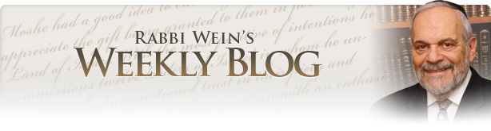
Airports

Over the past few months, I have traveled several times from Israel to the United States in order to attend happy occasions in my family. Because my children live in various areas of the United States, I always ask to transfer from the New York airports to fly to Chicago or Phoenix or Houston or St. Louis in order to fulfill my familial obligations.
I am very averse to having close connections between airplanes since I need assistance in the airport. I always give myself three or even four hours of leeway between the time that I land and my next flight. This invariably allows me to sit at the gate for a few hours before my plane departs and to observe the passing scene. Airports are fascinating places because as you sit there, the whole world walks by. Every color, creed, race, size, and attitude of human beings passes before your very eyes.
Most of the time, the people passing by are so intent on their own connections or to get to the baggage claim as soon as possible that nobody notices anybody in the great rush of humanity, especially in the large airports such as Chicago and New York. But as I sit on the side and watch, I have the time and the ability to look at the people and to, at least in my mind, form some sort of connection between them and me, even though obviously we are not related biologically, socially or religiously.
Nevertheless, I find it fascinating to imagine what type of lives these people have, where they are going and what they feel their purpose in life really is. Maybe this is too philosophical a way to observe people in an airport, but it certainly helps me pass the time while I am waiting for my plane.
The Torah teaches us that one of the wonders of G-d's world is that we are all constructed, so to speak, from the same diecast, and yet each one of those is so different from the other. It is not only the difference in appearance that is striking, but the appearance in attitude and worldview even though all of us have pretty much the same experience in life.
All of us experience good times and unfortunately not such good times. All of us have accomplishments and all of us have disappointments. Yet the human reaction to life itself is unique to every individual and no two people are alike. When I view the passing scene at the airport, my imagination runs away with me thinking about what the lives of those passing by me really constitute.

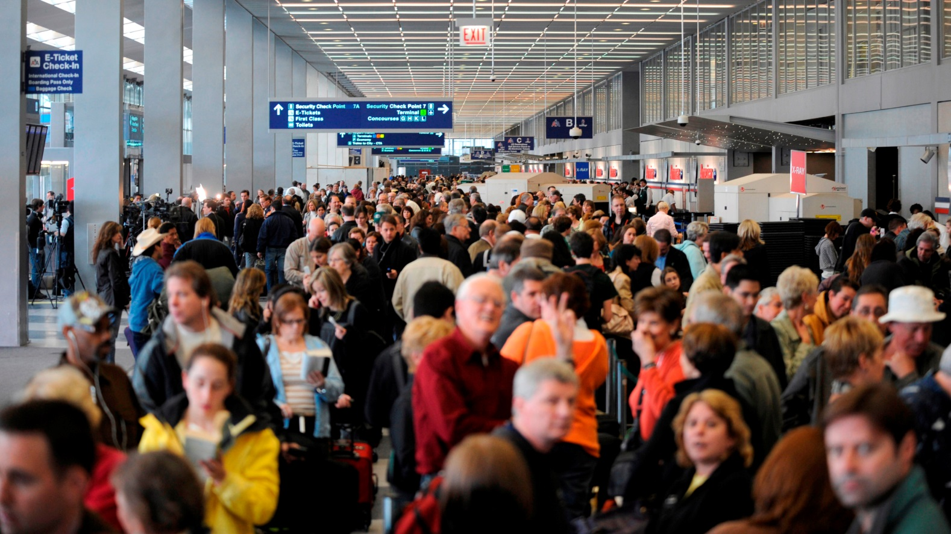
Photo taken at Chicago’s O’Hare Airport

The question always arises, "Why did the Lord make so many of us?" And I think part of the answer is that all human beings contribute directly or mostly indirectly to shaping the world that we live in and influencing all other human beings, even those we never see or know about. It is the collective race of humans that binds us together whether we wish it to do so or not.
The old joke was that the man said that it takes all kinds of people to make this world and I'm glad that I'm not one of them. But the truth of the matter is that each of us is one of them and we are bound mysteriously one to another, influencing and creating events and situations that eventually will touch the lives of those who pass by unnoticed. I think that's one of the great lessons of airports, because it allows us to view this diversity of people and to give free reign to our imagination as to why there are so many of them and why they are so different.
In today's world of international travel, one can see probably the greatest variety of human beings that has ever been on display in one place at one time simply by visiting an airport. Recently in Chicago, while waiting for my flight to New York, in the space of an hour, I saw every possible color, race and ethnic group that this world contains walk by in front of me. Not one of them took notice of me and being an old rabbi who oftentimes is bombarded by unwanted attention and questions, I enjoy that experience. Perhaps nobody likes being ignored all the time but occasionally it certainly has its benefit.
Invariably, and this has happened to me almost without exception, there always is someone at the airport who recognizes me and comes over to talk and reminisce. At my age and with my eyesight, I hardly ever recognize the person and what he or she is talking about, but I notice that the people sitting around me are impressed by the fact that someone stopped to say hello and to talk to me.
On my last trip when I was being wheeled through the airport, a man actually pursued me to shake my hands and to talk to me about the last time we had met 30 or 40 years ago and how he listened to my lectures, et cetera, et cetera.
The man who was pushing me in the wheelchair was duly impressed and said to me, "You must be one famous person." I said: "Well, I'm not really so famous. It just so happened that this man knew me."
He said, "No, that's not true because I push people all day long and no one ever stops to talk to them and it must be that you are special because someone did come over to talk to you."
Being duly flattered, I gave him a generous tip when he deposited me at the outside curb to wait for the car that was picking me up. But it’s true that you can be in a sea of humanity, literally with thousands of people and no one notices anyone else. No one stops to speak to anyone else, especially now since most are addicted to their mobile phones and are always somehow looking down at the phone and not up to people… and certainly not up to heaven.
In any event, airports are interesting places. And the miracle of aviation, which has revolutionized human life and travel, shrunken our world and made the most far distant places on the globe accessible to everyone, is truly one of the great inventions of all time. But people remain people and if you want to observe, I think that airports are a good place to do so.
So next time you travel, maybe you should come to the gate a little early and watch the parade passing by you. You may find it to be interesting and fascinating and it will give your imagination a chance to exercise itself in a manner we are not usually accustomed. But please make sure that you arrive at the gate in time and do not miss your plane.

Reprinted from the Parshat Tetzeveh 5780 website of Rabbiwein.com

How Iran’s Jewish Community Purchased the Tomb of
Esther and Mordechai
By Chen Malul

Documents discovered in the CAHJP archives reveal a surprising initiative undertaken by the Jews of Iran and the country’s government to mark 2,500 years since the Edict of Cyrus
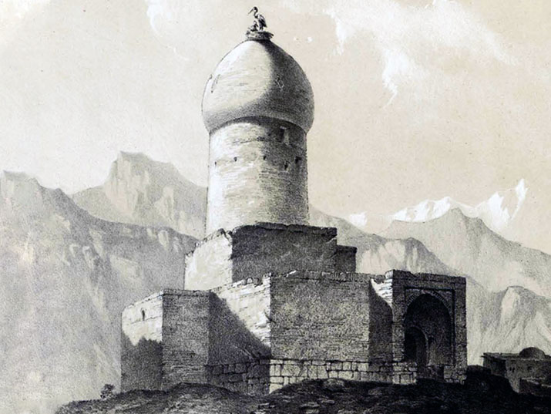
The tomb of Esther and Mordechai, a drawing by Eugène Flandin, 1851

It is not entirely clear whose idea it was, but in 1968, a vigorous correspondence developed between Jewish representatives in the Iranian parliament and officials from the regime of Shah Mohammad Reza Pahlavi, Iran’s ruler at the time.
The focus of this exchange was an attempt to purchase the Tomb of Esther and Mordechai at Hamedan. The pretext? Celebrations marking the 2,500th anniversary of the Edict of Cyrus, which were to be held in 1971.
The Edict of Cyrus dates to the year 538 BCE. In his historic declaration, Cyrus the Great, the founder of the first Persian Empire, allowed all peoples living in the territories under his control to return to the worship of their respective gods and deities, following the religious prohibitions which had existed under the newly-defeated Babylonian Empire.

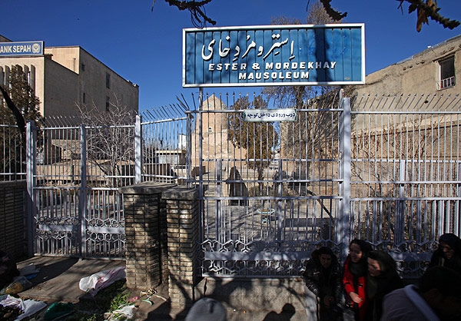The tomb of Esther and Mordechai at Hamedan

In the Hebrew Bible, (Ezra 1:1-4) we find a special version of the decree, addressing the People of Israel in the diaspora, and permitting them to return to Judea and rebuild the ruined Temple.
The first known account which links the mausoleum at Hamedan to the figures of Esther and Mordechai, the heroine and hero of the festival of Purim, comes from Benjamin of Tudela, a wandering Jewish traveler of the 12th century:
“From that mount to Hamedan is a journey of ten days; this was the metropolis of Media and contains about fifty thousand Jews. In front of one of the synagogues is the sepulchre of Mord’khai and Esther.”
According to one of the traditions associated with the tomb, after the death of King Ahasuerus, the followers of Haman sought revenge against Esther and Mordechai. The two managed to escape to Hamedan, where they settled down and eventually passed away at a ripe old age among the local Jewish community.
But what does all this have to do with Cyrus the Great? At first glance, very little at all. However, it is clear from certain letters discovered at the Central Archives for the History of the Jewish People (CAHJP), in the archive of the World ORT Union organization, as well as from historical sources relating to the life of Iran’s last Shah, that Mohammad Reza Pahlavi saw himself as the modern heir of Cyrus the Great, and sought to project this image of himself to the Jews of his country. The 2,500th anniversary of the Edict of Cyrus was exactly the kind of event he was waiting for.

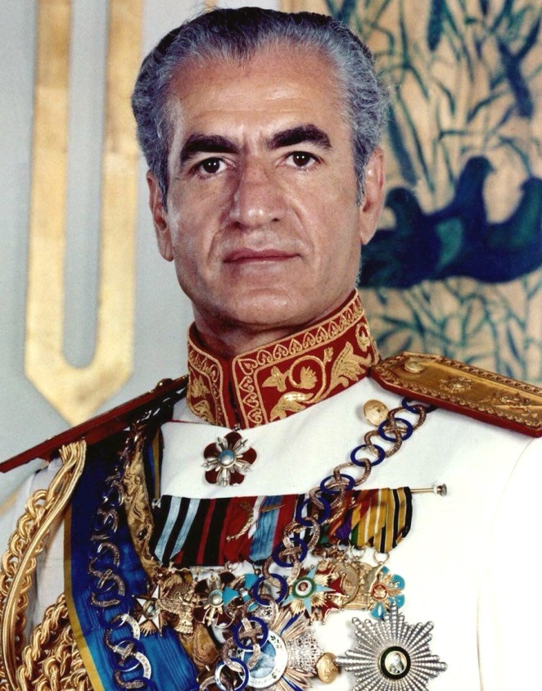
Mohammad Reza Pahlavi, the last Shah of Iran

In a letter sent by the director-general of the Department of Archaeology and Public Education, Mr. Abdolali Pourmand, to Mr. Lotfollah Hay, the representative of Iran’s Jews in parliament, Pourmand clarified that the office of National Education would assist the Iranian Jewish community in purchasing the tomb and the land surrounding it from the Bazargani Bank, its owner at the time. The purchase would be funded by the selling of tickets to the site.

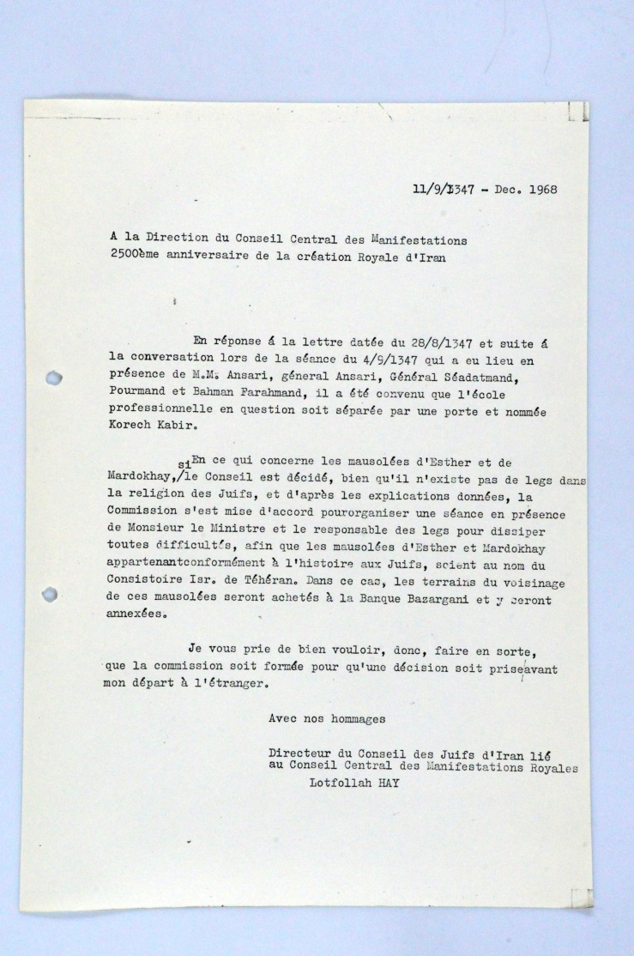
Correspondence between the Jewish parliament member and the representative of the regime, December 1968; the Central Archives for the History of the Jewish People at the National Library of Israel

In the correspondence, the sense of urgency expressed by the regime’s representative is clear. Pourmand pressed the Jewish community to reply to the initiative – with an affirmative response being the obvious preference – as the department’s queries had so far gone unanswered.
In addition to the tomb-purchasing initiative, the Jewish community also planned to build a vocational school named after Cyrus the Great, as well as a hospital. There were even plans for a Hebrew-Persian dictionary and an exhibition dedicated to Cyrus’ achievements which would focus on the topic of Torah-based human rights, in various languages. It is unclear how much of all this actually came into being. The archives, however, do include evidence that the purchase of the grounds of the tomb was indeed completed, with final approval arriving on January 18th, 1970. It appears that the land was transferred into the hands of the community – though it is difficult to say for certain as the documentation ceases at this stage.

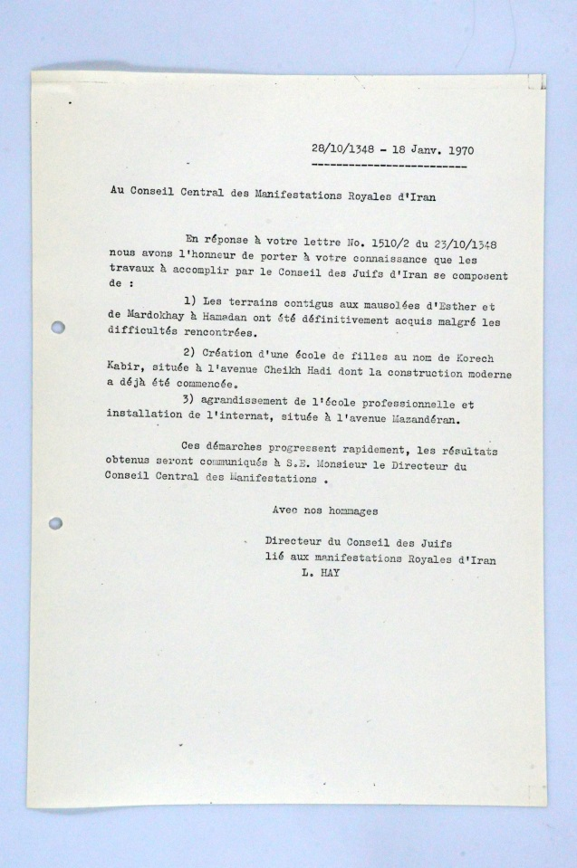
A letter certifying that the grounds of the tomb were purchased; this is also the latest document found in the correspondence, from January 18th, 1970; the Central Archives for the History of the Jewish People at the National Library of Israel

The honeymoon period between the Jews of Iran and the state authorities would come to a quick, cruel end with the Islamic Revolution of 1979 and the rise to power of Ayatollah Ruhollah Khomeini. This event also saw the last Shah of Iran, “The New Cyrus”, flee the country for the United States.
Since then, the tomb of Esther and Mordechai has been the focus of bitter dispute. In 2011, regime-supporting students rioted outside the compound and called for its removal from the list of protected Iranian heritage sites – as a response to their claims that Israel was seeking to destroy the al-Aqsa Mosque. Their efforts were something of a success, with the sign noting the tomb’s status as a site of pilgrimage being removed. From time to time, protesters from across Iran issue threats to destroy the tomb and replace it with a Palestinian consulate. A recent incident of this kind occurred in February. So far however, the site remains intact, with only Jews allowed entrance to the tomb enclosure.
Despite the long-standing tradition linking the tomb to the figures of Esther and Mordechai, scholar Thamar Eilam Gindin tells us that Persian or Iranian sources do not contain any evidence attesting to the story of the Megillah, the story of Purim. One of the leading theories today suggests that the tomb is actually that of Shushandukht, the Jewish wife of Yazdegerd I, a ruler of the Sasanian Empire during the fourth and fifth centuries.
The city of Hamedan was once the capital of Media, which was captured by Cyrus the Great, who made it the summer capital of the Persian Empire. Today Hamedan is associated with the city of Ecbatana, mentioned in the Book of Ezra.

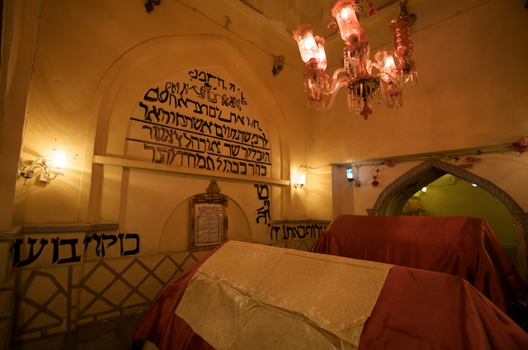The interior of the tomb, photo by Nick Taylor

Many thanks to Thamar Eilam Gindin for her assistance in the preparation of this article, to Elitsour Lion for his translations and to Dr. Miriam Caloianu from the Central Archives for the History of the Jewish People for sharing this story with us.

Reprinted from the March 9, 2020 email of the National Library of Israel.
Updated Every Minute, 17-Year-Old Whiz Kid’s Coronavirus Site Used by Millions Around the World
By Renee Ghert-Zand

A self-taught computer maven from Seattle, Avi Schiffmann uses web scraping technology to accurately report on developing pandemic, while fighting misinformation and panic

Avi Schiffmann working on his ncov2019.live website (David Schiffmann)

A Jewish teenager from the Seattle area has built a website that is keeping the world updated on the COVID-19 pandemic as it spreads. The website, ncov2019.live, has been visited by 12 million people since it launched in late December.
Computer whiz Avi Schiffmann, 17, spends much of his time these days constantly updating and improving the website, which automatically scrapes data from reliable sources from all over the world. The site, which originally updated every 10 minutes, now updates every minute to provide the latest statistics on the number of confirmed cases, serious cases, deaths, and recovered — both worldwide and in each country — in real time. The site also hosts an interactive Google map, a Twitter feed, travel advisories, information on the disease and its prevention, as well as tips for preparing for quarantine situations.

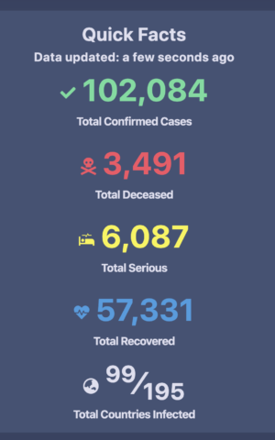
Detail from the ncov2019.live dashboard,
which is updated every minute. (ncov2019.live)

“I started working on this project at Christmastime, when there were fewer than 1,000 confirmed cases — all in mainland China,” said Schiffmann, a high school junior. “It was hard to get clear, concise, and accurate information on what was going on, and I wanted to do something to fix this.”
Schiffmann, who is working on a variety of different coding projects concurrently, decided to tackle this particular one primarily because it would enable him to learn web scraping technology.
“It would also be a way to help with global health, which is something that’s needed when not all governments are the nicest or transparent, and it is hard to get information,” he said.

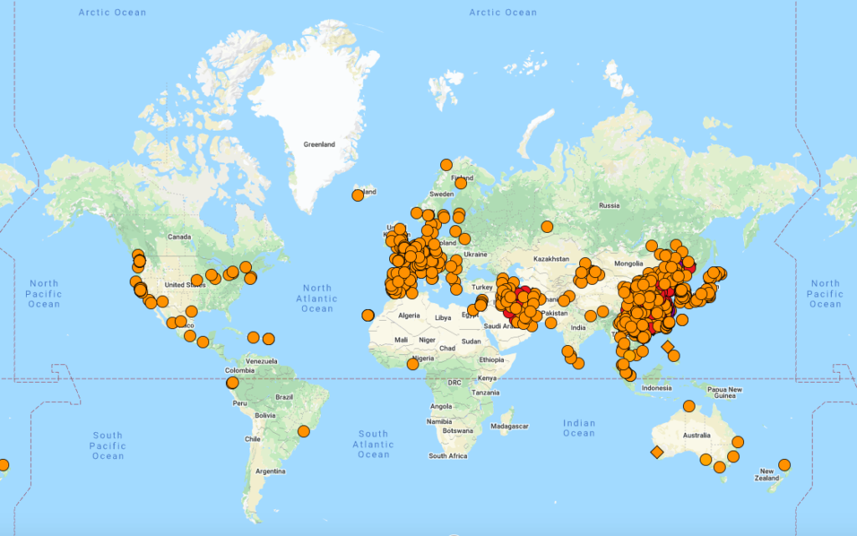
Screenshot of map tracking spread of COVID-19 pandemic on ncov2019.live website (ncov2019.live)

Schiffmann’s website scrapes information from many different sources, including official government health organizations (local, national, and international), and trustworthy news outlets. He relies on an online community of news curators to help with this. He also coded the website to crosscheck data to make sure it is accurate.
“It’s all automated, so I don’t have to input anything manually. The web scraper runs even when I’m sleeping,” he explained.
Planned improvements to ncov2019.live include regional statistical breakdowns, graphs comparing the COVID-19 outbreak to historical pandemics, a vaccine tracker, and translation of the site to 30 different languages.
“I am getting 1,000 messages a day. Some are from people thanking me for the site, some are from media outlets reaching out for interviews, and many are from PhDs who have suggestions for information I could add,” Schiffmann said.

A customer walks past mostly empty shelves that normally hold toilet paper and paper towels at a Costco store in Teterboro, New Jersey. (AP Photo/Seth Wenig)

Even in English only, the site has been visited by individuals in every country on earth, with less than half from the United States. As word has gotten out in the mainstream media about Schiffmann and the site, the number of visitors has grown exponentially. Whereas it took a month to reach the first million, just in the past 24 hours alone the site was visited by 3.2 million people, including 30,000 from Israel.
The teenager, who plans to take a year or two off after high school to travel the world to participate in hackathons, hopes to become a serial entrepreneur. He said he isn’t in it for the money, but rather to be creative and make an impact.
“I want to have the skills to make the next big thing, to change the world. I’m not interested in imitating anyone else. I want to be the next Avi Schiffmann,” he proclaimed.

Detail from the ncov2019.live dashboard, which is updated every minute. (ncov2019.live)

The eldest child of a physician mother and a biologist father, Schiffmann moved around a lot while growing up, living in Israel, Ireland, the UK, and in six American states. One constant was his passion for coding, which he began to pursue at age seven. An autodidact, he taught himself most of what he knows from online tutorials and networking with online communities.
“I use coding like a painter uses a paintbrush. I like the technical aspect, but it’s a creative medium for me. I like making things and sharing them,” he said.
For Schiffmann, who already knows what he wants to do in life, school is something to merely get through.
“My grades aren’t so good. I do what I have to to pass my courses. I spend 100 percent of my time on computer stuff,” he said.
When asked whether he ever stops looking at a computer screen, Schiffmann shared that he enjoys traveling and that he also skis competitively.
“I prefer the giant slalom, but I also have slalom skis” he said.
While Schiffmann is pleased that the attention he has gained from his coronavirus tracking website has landed him many internship and job offers, he hasn’t forgotten the main purpose of the project. The website is meant to help, and not add to the growing panic as the disease spreads.
“I have to admit that it is pretty scary, especially here in Seattle which is the epicenter from which the virus spread in this area. There have been a lot of school closures and cancellations of events. It’s a ghost town around here,” he said.
Schiffmann is critical of governments’ responses to the crisis. “They are not transparent and are trying to save face, and then it is too late. The world needs to be much more prepared for these kinds of things,” he said.
“For instance, my mom is a doctor, and she was finally able to get test kits for her patients only now,” he said.
Schiffmann said he was concerned about the spread of misinformation, such as the unproved theory that the virus is seasonal and will soon disappear, and blamed the media for causing unnecessary panic.
“People should have preparedness plans and stock up in advance instead of going on panicked Costco runs now,” he said.
In the meantime, Schiffmann is doing his part to help people access accurate information and keep their anxiety in check. It’s a lot of responsibility for a teenager to shoulder, but Schiffmann hopes the missed hours of sleep for him now will translate into a better future for everyone.
“But who knows — in three years we could be having this conversation again,” he said.

Reprinted from the March 10, 2020 website of the Times of Israel.

As the Coronavirus Epidemic Looms, American Jews Brace For a Shabbat Like No Other
By Ben Harris and Josefin Dolstein

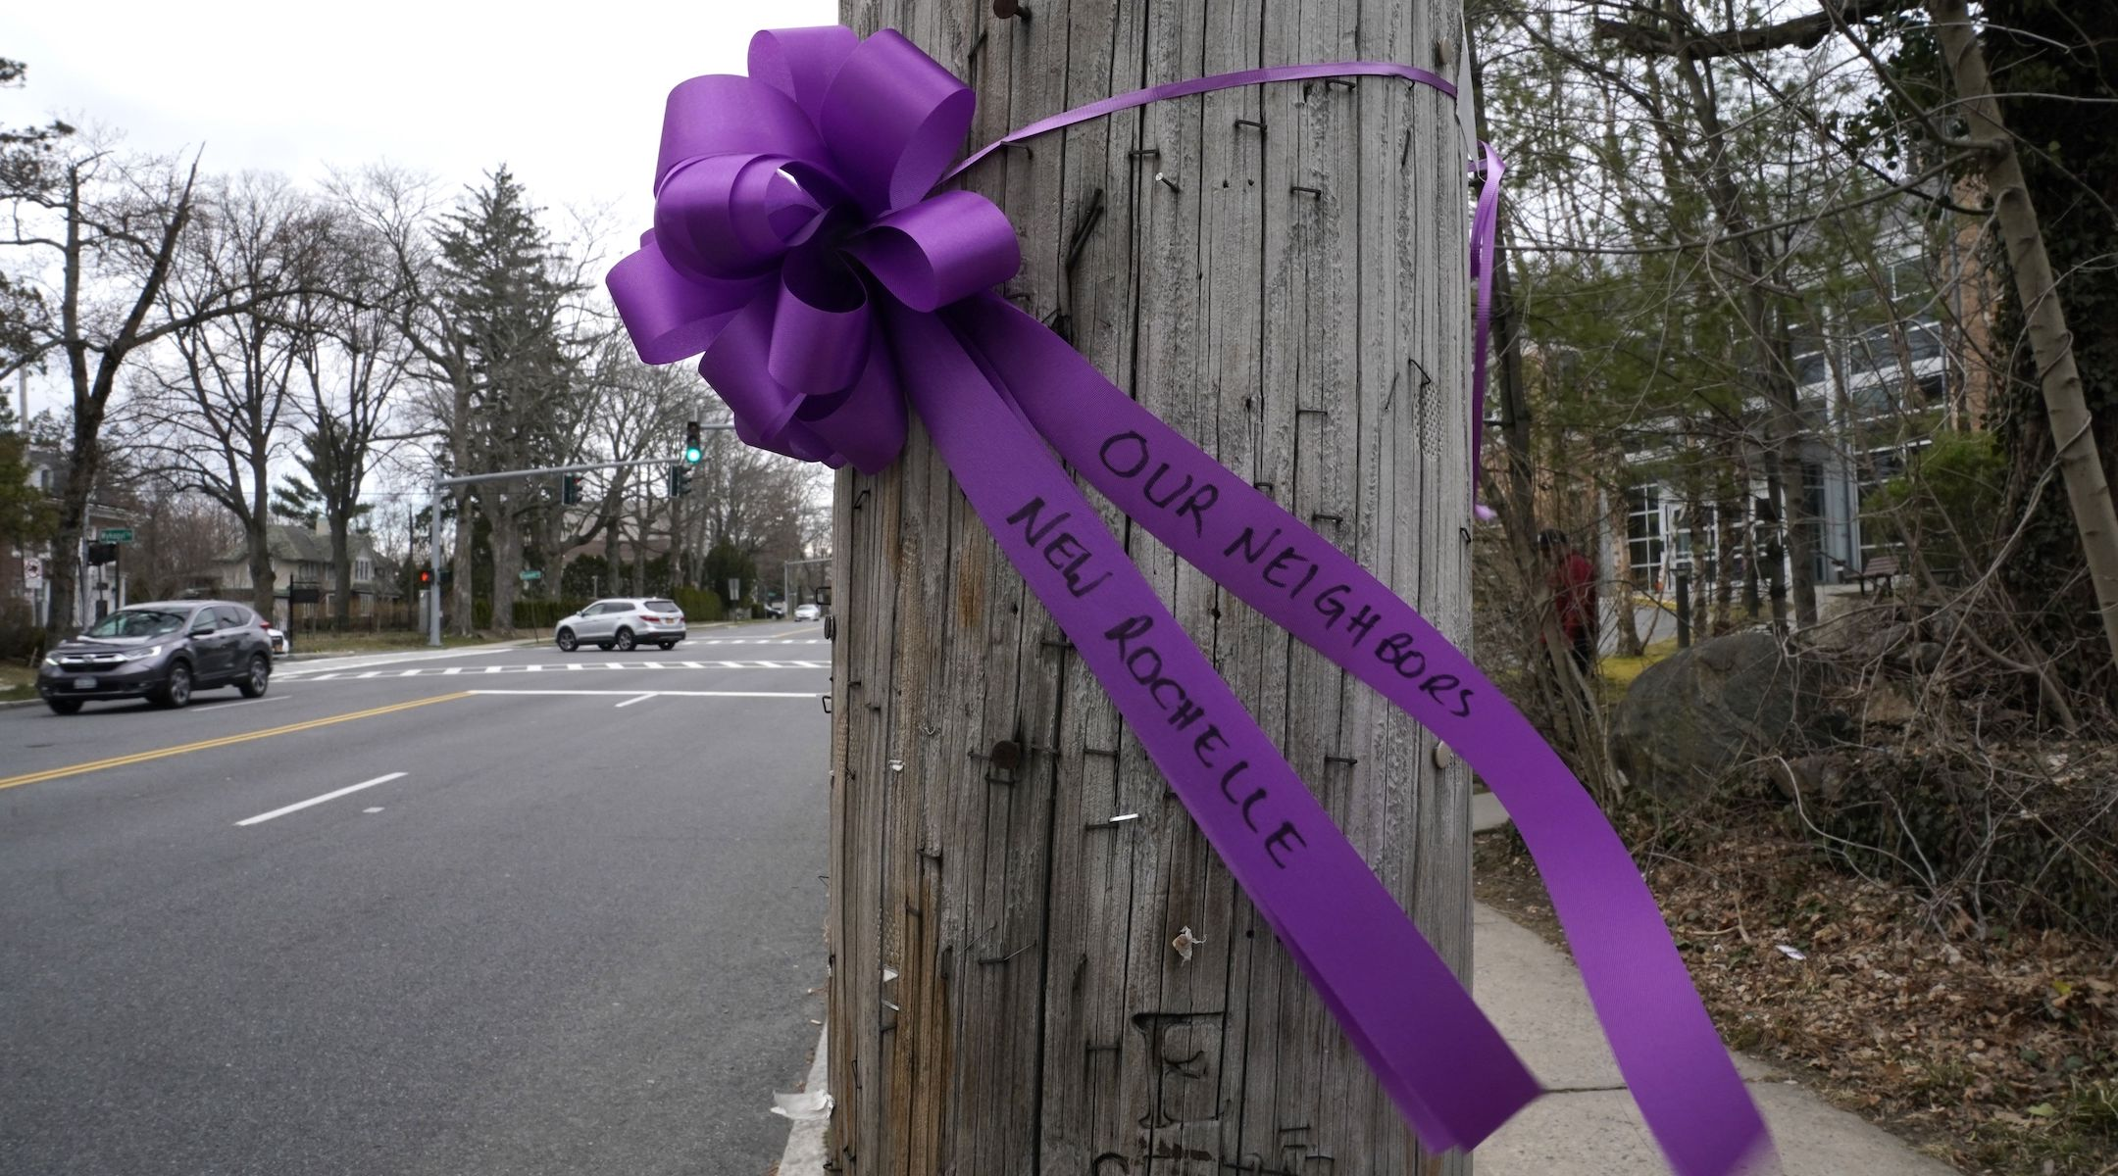
A ribbon expressing support is tied to a pole outside the Young Israel of New Rochelle synagogue, in New York's Westchester County, which was quarantined after a member tested positive for the coronavirus, March 10, 2020. (Timothy A. Clary/AFP via Getty Images)

NEW YORK (JTA) — As of Thursday, Alex Matthews felt confident that the synagogue he leads in Newburyport, Massachusetts, would be able to hold services as scheduled this Shabbat.
Even as growing numbers of Jewish communities began shutting down schools and synagogues and, when possible, moving operations online, Congregation Ahavas Achim sent an email to its membership announcing its intention to hold prayers as planned on Saturday morning.
But as the day unfolded Thursday, cancellation emails came flooding in from his colleagues elsewhere. By late Friday morning, the synagogue had reversed course, joining a growing consensus that the most religiously appropriate way to respond to the coronavirus epidemic is to cancel all public synagogue activities.
“If we would have had Shabbat services tomorrow morning, we would have gotten 10 to 15 people and I would likely be the only one in the room not in an elevated risk group,” Matthews told the Jewish Telegraphic Agency on Friday afternoon. “As much as I want to continue with life as normal and provide a spiritual outlet for people, I think the reality on the ground needs to be one of utmost caution.”
That approach has taken root in an an ever-widening circle of Jewish communities as the Jewish world braces for a Shabbat unlike any other. From New York to Chicago to Dallas and beyond, a cascade of communities began cancelling synagogue services and other public gatherings as the Jewish Sabbath drew near.
In non-Orthodox communities, many synagogues have chosen to move their Shabbat prayers online — something that would have been unthinkable just a week ago. In Orthodox communities, where the use of electronics is strictly prohibited on Shabbat, growing numbers of synagogues made the equally unprecedented decision to cancel services entirely. Across all communities, meals and other gatherings that are typical on Shabbat have been called off.
“It’s very painful,” said Maharat Ruth Friedman of Ohev Sholom-the National Synagogue in Washington, D.C.
Like many synagogues, Ohev Shalom was hopeful as recently as Thursday that it could still hold services as planned this Shabbat, even as it canceled other events deemed less central to religious life. Their one concession to the virus was moving Saturday morning services an hour earlier to communicate that this was not a time for socialization. The community would gather to perform an essential ritual of religious life and then disperse.
But as the weekend drew near, and after consulting with local officials, the synagogue decided even that was not a risk they could take.
“We take very seriously both prayer from a religious perspective but also really ensuring that there’s community available, especially for folks who live alone or really rely on the shul not just for the religious space but for the social communal space as well,” Friedman said. “So to make the decision that we’re shutting doors when we never make that decision, it’s very difficult. It’s not something we take lightly.”
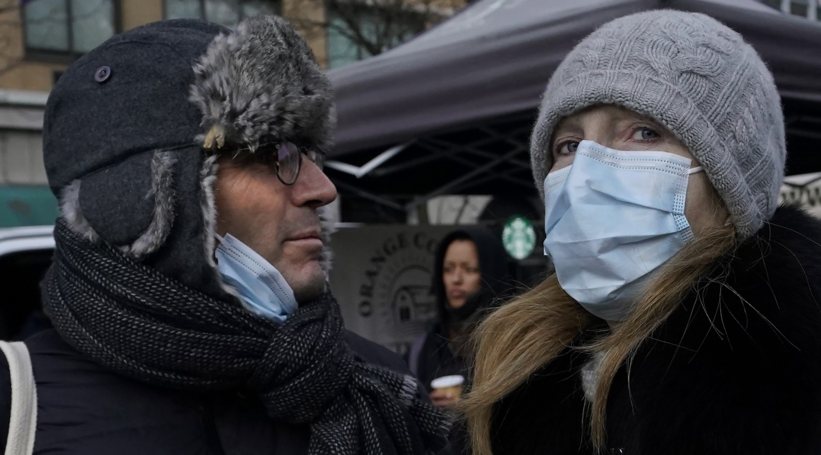
People wearing masks to protect from the coronavirus in New York’s Union Square, Feb. 28, 2020. (Timothy A. Clary/AFP via Getty Images)

Concerned that synagogues were letting that reticence impede efforts to protect communal health, Rabbi Robert Harris, a professor at the Jewish Theological Seminary, posted an urgent appeal on Facebook Thursday. Invoking the Jewish principle of pikuach nefesh, the idea that the imperative of protecting human life overrides all other religious considerations, Harris urged rabbis of all denominations to issue a temporary decree permitting the streaming of religious services.
“I was concerned the day before yesterday,” Harris told JTA. ”My understanding was that certain rabbis and synagogues were considering keeping their congregations open and I was alarmed at that because I thought that the reasons that they were hesitating were not in keeping with the primacy of pikuach nefesh, of preserving human life over other considerations which are ritual, meaning the observance of Shabbat.”
Some of the American Jewish communities most deeply affected by the virus remain in the greater New York City area, where Jewish individuals were among the first confirmed cases of the disease and some schools and synagogues have already been shuttered for a week.
In northern New Jersey, the Rabbinical Council of Bergen County adopted some of the most sweeping measures to contain the spread of the disease on Thursday when it ordered all synagogues to be shut down and forbade Shabbat gatherings in people’s homes — a mainstay of religious life for countless Jews in the area.
But communities across the country are taking similar steps. At the Young Israel of West Hartford, in central Connecticut, all synagogue classes were moved online and the daily prayer service was moved from the basement to the larger sanctuary upstairs to allow for more distance between worshippers. In Skokie, Illinois, coronavirus cases confirmed Friday morning caused synagogue activities that remained on the schedule to be called off. A statewide closure of houses of worship in Kentucky meant no Jewish communities would convene there.
“I think it’s on everyone’s mind,” said Tuvia Brander, the rabbi of Young Israel. “I think we’re all trying to take this very seriously and do that in a way that’s responsible and driven by knowledge and information from medical professionals, local health and government leaders.”
At the Skylake Synagogue in North Miami Beach, services are going ahead as scheduled this Shabbat, but nothing else — no post-service kiddush, no meals, no social events. Congregants are being urged to bring their own prayer books, to keep ample distance from one another, and to avoid kissing the Torah, as is traditional. Three weddings in the community have been canceled.
“We’re reassessing the situation all the time,” said Rabbi Ariel Yeshurun. “Right now we are not in the same reality that the folks up there in New York, up north, are experiencing, but if it does develop and if it does get to it, and the situation is very fluid right now, we are constantly holding meetings and conference calls and we will reassess.”
One synagogue that held a particularly fraught meeting this week was Congregation Beit Simchat Torah in Manhattan, which faced an acute dilemma — Naomi Springer-Galst was due to celebrate her bat-mitzvah at the synagogue on Saturday morning.
On Thursday, the LGBTQ-friendly synagogue announced that it would still hold services, but asked only close family and friends to attend in person. Everyone else was invited to follow along on a Facebook livestream.
“Our synagogue has been through a plague before — 40% of our congregation in the AIDS crisis,” Kleinbaum said. “I know what it takes to survive as a community through terrible loss, and resiliency and joy and spirituality is center to it. I know what my job is and I feel a deep sense of faith — not that everything is going to be OK, because I know how horrific the world could be, but a deep sense of faith that people can find great wisdom and learn deep things and reveal God’s presence even in these terrible times.”
Reprinted from the March 13, 2020 dispatch of the JTA (Jewish Telegraphic Agency.)
G-d and the Coronavirus
By Rabbi Benjamin Blech

What could be the meaning of a virus forcing millions into a “timeout” of quarantine and seclusion?

Coronavirus is now officially a global pandemic. Suddenly we find ourselves smitten by a plague of biblical severity.
Passover asks us to remember the 10 plagues which G-d sent against the Egyptians. With the help of the Bible we know the purpose behind these afflictions of a people. G-d had a plan. Egyptian suffering had meaning. What makes our contemporary anguish so particularly unbearable is its seeming incomprehensibility.
In the age of the prophets there would’ve been an effort to discern some divine message in this global tragedy. But today we somehow assume that scientific knowledge precludes the possibility for including G-d as part of the management of the universe. After all who can argue with Louis Pasteur and Robert Koch who, in the latter half of the 19th century, proved the germ theory of disease – that pathogens too small to see without magnification are the true cause of illness. Germs are the villains and viruses are the sole reasons for the presence of diseases which determine whether we live or die.
And I dare to ask: Doesn’t belief in G-d demand that we merge the germ theory of disease with the conviction of faith in a supreme being who actually decides where, when and how far viruses spread?
Please understand exactly what I’m saying. Maimonides long ago made clear that it is our obligation to ensure our good health. We can’t simply rely on G-d; G-d has made us his partners in our quest for longevity. Hygiene is a mitzvah; it's an obligation. Taking care of our bodies is a spiritual requirement akin to protecting our souls. When we are directed by doctors to wash our hands we are required to do so by Torah law.
But the ultimate decision of life or death remains, as we make clear every year on Rosh Hashanah and Yom Kippur when our fate is sealed, with the Almighty.
That is why I’m amazed that of the countless suggestions for how to counter and to cope with the coronavirus we hear so little of the word God and the possibility that this global pandemic brings with it a profound divine message.
I am obviously no prophet, but here is a thought that I think is worth considering and taking to heart. Every parent knows that one of the most obvious responses to a child’s misbehavior is what is commonly known as a “timeout.” The child is restricted from enjoying pleasurable activities. The child has his normal life disrupted. The child is encouraged to reflect upon his disobedience. Is it too much to consider that as our world continues to sink ever lower in our commitment to virtue that God responded with a virus that has forced millions into a “timeout” of quarantine and seclusion?
The 10 Commandments are the biblical source of the most basic system of ethical and moral behavior. They represent the primary justification for our continued existence on earth. And the commentators took note of a remarkable number. In the original Hebrew, the language in which the commandments were inscribed by God on the two tablets, there are exactly 620 letters.
620 would seem to be a number with no particular theological significance. It would’ve been perfect and readily comprehensible if there were exactly 613 letters in the 10 Commandments. Those are the numbers of mitzvot given to the Jewish people in the Torah. The 10 Commandments are the principles inherent in all of Jewish law. But what is the meaning of 620 letters? The rabbis explained. While the number of mitzvot for Jews is 613, the number seven represents universal law – what is commonly referred to as the seven laws of the descendants of Noah, required as a minimum for all of mankind. And 620 of course is the sum of 613 and seven, the totality of divine guidance for both Jews as well as the rest of the world.
The commentary does not end there. 620 is the gematria, the numerical value, of an important Hebrew word, keter, which means crown. A keter – a crown – is placed on top of every Torah scroll. The symbolism is obvious. The crown above the Torah demonstrates the relationship of the 10 Commandments to the rest of the Torah. From the 10 – in number of letters 620 – we have the principles which subsequently found expression in the entirety of the Torah.
The keter – the crown – is the most powerful symbol of our connection with G-d.
The word corona – as in coronavirus – comes from the Latin word for crown.
Perhaps we need to consider the world’s present affliction not just in the context of a disease caused by pathogens but as a divine message reminding us that we have been given our lives to invest them with meaning and virtue as defined by G-d's 10 Commandments.

About the Author
Rabbi Benjamin Blech
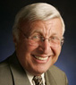
Rabbi Benjamin Blech, a frequent contributor to Aish, is a Professor of Talmud at Yeshiva University and an internationally recognized educator, religious leader, and lecturer. He is the author of 19 highly acclaimed books with combined sales of over a half million copies, A much sought after speaker, he is available as scholar in residence in your community. See his website at rabbibenjaminblech.com.

Reprinted from the March 15, 2020 posting on Aish.com website.

HISTORY
The Story of the
Synagogue Chumash
By Yosef Lindell

The Ferrara Bible, the first printed Spanish translation of the Chumash by ex-converso Solomon Usque, was originally published in 1553. The title page here is from the 1661 edition. Courtesy of the Kislak Center for Special Collections, Rare Books and Manuscripts, University of Pennsylvania
When you walk into shul on Shabbat morning, which Chumash do you choose? Do you take one with Hebrew only, or one with English translation and commentary? Do you use the ArtScroll? Something else? How much thought do you put into your choice?
Obviously, every shul Chumash contains the same Torah, but each edition has its own flavor. It’s worthwhile to consider how they differ, for the story of the Chumash is the story of how the timeless Torah continues to be presented in new ways.
First, what is a Chumash?
In the Mishnah (Yoma 7:1 and others), the word chumash refers to a chomesh—one-fifth of the Torah (i.e., one book). Over time, however, the word came to mean what it does today, an abbreviation for Chamishah Chumshei Torah—a single book or codex containing all five-fifths of the Torah.
The codex, or bound book, was invented around the year 300 ce, but we do not have any Chumashim that old; the earliest ones we have today are from around 1,000 years ago. Chumashim were not widely available in the Middle Ages, as only wealthy individuals could afford a scribe to write the manuscript. Although they were not produced exclusively for synagogue use, many medieval Chumashim contain haftarot or even Shabbat davening, suggesting that they were intended to be used in shul. The invention of the printing press (in the fifteenth century) made Chumashim more affordable and widespread.

A Survey of Translations
In today’s user-friendly shul Chumashim, translation is a central component. Surveying these translations will help us understand the differences between the editions available today.
The Mishnah in Megillah (4:4) recounts the ancient practice of oral translation: after the Torah reader completed one verse, a designated individual would recite the Aramaic targum, or translation, aloud. The Gemara (Megillah 3a) traces this practice all the way back to Ezra’s public reading of the Torah (Nechemiah 8:8). Some targumim, most famously Targum Onkelos, are largely literal renderings of the Torah. Others, such as the one commonly known as Targum Yonatan ben Uziel, are far more midrashic, expanding upon the Torah’s narrative with interpretation and even lengthy additions.
Beyond Targum, the Torah has been translated into the vernacular of nearly every land that Jews have called home. The Greek Septuagint was probably completed a few hundred years before the Common Era. There is also Rav Saadiah Gaon’s tenth-century Arabic Tafsir. The ex-converso Solomon Usque’s 1553 Ferrara Bible was the first printed Spanish translation of the Torah. And the noted scholar and commentator Rabbi Samuel David Luzzatto, or Shadal, published a translation of the Torah into Italian in 1858.

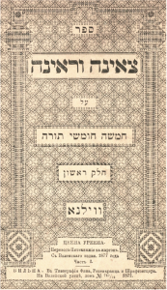
Tz’enah Ur’enah, a free-flowing midrash on the Torah, was reprinted hundreds of times after being published ca. 1600. This 1877 Vilna edition was rescued from the Nazi Einsatzstab Reichsleiter Rosenberg (EER) unit and returned to YIVO by the US Army after World War II. Courtesy of the Library of the YIVO Institute for Jewish Research, New York

Translation did not take hold with the same fervor in Yiddish-speaking parts of Europe. Despite an oral tradition for translating individual Hebrew words in the Torah into Yiddish dating back to the Middle Ages, few full Yiddish translations were attempted. One notable exception, the 1544 Taytsch Chumash, which was spearheaded by a Christian Hebraist publisher, was nearly unreadable due to an over-literal approach to translation that used Hebrew instead of Yiddish syntax. It sold few copies.
Later Yiddish versions were called Chumash mit Chibbur, which was more of a running Yiddish commentary than a literal translation, with the interpretive portion frequently paraphrasing Rashi. More popular than any translation was Tz’enah Ur’enah, a free-flowing midrash on the Torah by Yaakov ben Yitzchak Ashkenazi. Tz’enah Ur’enah, first published around 1600, was reprinted hundreds of times in the following centuries. The popularity of Chumash mit Chibbur and Tz’enah Ur’enah demonstrates that for many traditional Jews, Chumash and Rashi were inseparable, and rabbinic exegesis and commentary were part and parcel of what the Torah really means.

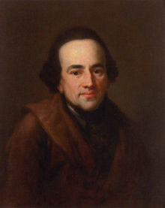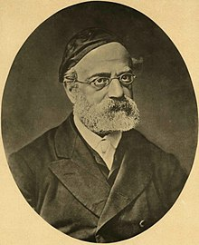
Moses Mendelssohn Rabbi Samsom Raphael Hirsch

It is in this very traditional milieu that Moses Mendelssohn made waves in 1783 with the first-ever German translation of the Torah. At first glance, Mendelssohn’s work, called Netivot haShalom, doesn’t look so different from the classic Mikraot Gedolot. Mendelssohn’s Be’ur commentary, for example, is in Hebrew and draws exclusively from traditional commentaries. But Mendelssohn also used Hebrew characters for the German translation, suggesting that he wanted traditional Jews to learn German and integrate into German society as he had. Indeed, Mendelssohn’s Chumash aroused the ire of some in the rabbinical establishment.
By the time Rabbi Samson Raphael Hirsch published a new German translation with his own extensive commentary in 1867, many more Jews spoke German, and Rabbi Hirsch saw a need to counter the growing Reform movement and to impart traditional values to an assimilating German Jewry. Unlike Mendelssohn’s commentary, Rabbi Hirsch’s is original, synthesizing his unique approach to Jewish thought, the meaning of mitzvot, and the etymology of Biblical language. Rabbi Hirsch’s commentary is particularly striking because it is one of only a handful of Torah commentaries written in the vernacular up until his time.

Contemporary Chumashim
English translation followed a different path. For quite some time, English-speaking Jews were content to use slightly modified versions of the seventeenth-century King James Bible—such as David Levi’s 1787 Bible or Michael Friedlander’s 1884 Jewish Family Bible—which remove overtly Christian renderings. Even the 1917 Jewish Publications Society (JPS) translation, which set the standard for scholarly English translations by Jews, relied on the King James instead of starting from scratch, and remains highly similar to it in substance and style; many verses are nearly identical.
Perhaps Jewish dependence on the King James speaks to how faithfully its translation hews toward literalism and how well it captures the rhythm of the Hebrew.

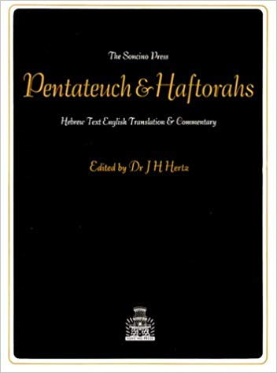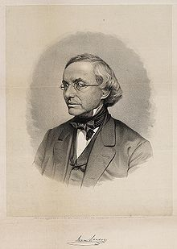
The Hertz Chumash Isaac Leeser

The story of the Chumash is the story of how the timeless Torah continues to be presented in new ways.
But not everyone was comfortable with the King James. Isaac Leeser, the nineteenth-century American communal leader, writer, and editor of the Occident, deplored Jewish reliance on “a deceased King of England, who was certainly no prophet, for the correct understanding of the Scriptures.” In 1845 he published his own Chumash, which includes his translation (ironically still quite similar to the King James) and a short commentary that largely paraphrases Rashi. Leeser’s Chumash was widely used in English-speaking synagogues until the early twentieth century.
You won’t find Leeser on the shul bookshelf anymore. But you will probably still find the Hertz Chumash. British Chief Rabbi Joseph Hertz’s 1936 one-volume Pentateuch And Haftorahs was revolutionary. Although Rabbi Hertz used the JPS translation, he composed (with assistance) a wide-ranging English commentary highlighting traditional and modern scholarship that defends the Torah from Biblical criticism. The Hertz Pentateuch was the standard shul Chumash in American synagogues, Orthodox or not, until the 1980s and beyond. The Conservative movement used it nearly exclusively until 2003.
This is not to say that there were no alternatives to the Hertz Chumash. In 1947, the publisher Soncino released another English Chumash with the JPS translation, but instead of Rabbi Hertz’s commentary it includes summaries of comments by Rishonim such as Rashi, Ibn Ezra, Ramban and others. It was also quite popular, and you might still find it on the shelf.

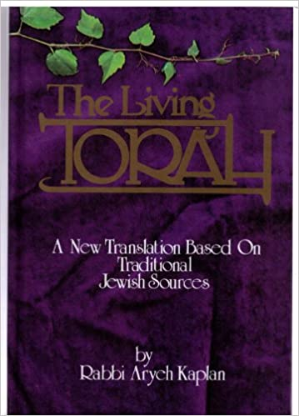
Rabbi Aryeh Kaplan’s The Living Torah

In 1983, Dr. Philip Birnbaum, famed for his “Birnbaum Siddur,” published a Chumash translation with a terse commentary, but I’ve never seen his Chumash in shul. Rabbi Hirsch’s commentary was excerpted and translated into English by Gertrude Hirschler in 1987, exposing synagogue goers to Rabbi Hirsch’s thought (although without the linguistic elements). The Hirsch Chumash is still widely used in shuls today, and has gone through several editions.

More significant from a translation perspective was Rabbi Aryeh Kaplan’s The Living Torah Chumash. First published in 1981 and then in a Hebrew-English edition in 1985, it was the first Chumash intended for shul use not shackled to the King James’ archaic language and flowery style. The Living Torah is light on commentary, but features a modern English translation and includes English subheadings to guide the reader topically. The Living Torah translation is refreshingly colloquial, but perhaps at the expense of being sufficiently literal. For example, Rabbi Kaplan translates “yom hasheviyi” in Parashat Bereishit as “Saturday.”

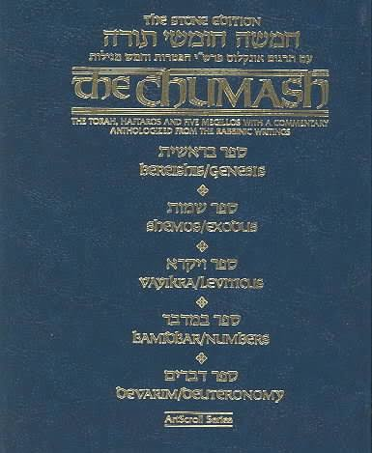
The Stone Chumash

It was ArtScroll’s 1993 Stone Edition of the Chumash that set a new standard. In many contemporary middle-of-the-road and Modern Orthodox shuls, it now dominates the shelves. An attractive faux-leather volume with charts, pictures, a new translation and a commentary anthologized from a wide range of traditional commentaries, the Stone Chumash rapidly replaced the aging Hertz Chumash.

Return to Rashi
But the Stone Chumash is not an updated version of the Hertz. It does not attempt to engage Biblical critics, and in fact, its editors saw no need to draw on non-Jewish or non-religious sources at all. Instead, ArtScroll’s editors rely solely on traditional commentaries, and believing that Rashi most closely reflects Chazal’s understanding of the Torah, prioritize his commentary over others. Likewise, the far-less-popular 1999 Margolin Edition Torah from Feldheim Publishers (which does not include a commentary) emphasizes Onkelos and Rashi in its translation, explaining that a purely literal rendering of the words (if there is such a thing), is counter to the purpose of translation, which is to elucidate the text according to Chazal.

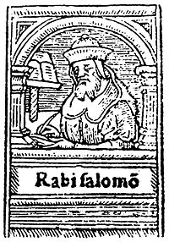
16th-century depiction of Rashi

Beyond Targum, the Torah has been translated into the vernacular of nearly every land that Jews have called home.
The return to Rashi is most pronounced in two one-volume shul Chumashim published by different arms of the Chabad-Lubavitch movement. The 2006 Gutnick Edition, published by Kol Menachem, calls Rashi “basic to the understanding of the text of Chumash,” and states that each comment of Rashi, no matter how “elaborate it may be, is required in order to understand the literal meaning of Scripture.” Thus, its translation follows Rashi, and the commentary also focuses heavily on Rashi. This edition also includes many insights from the Lubavitcher Rebbe, who believed that Rashi was of supreme importance for understanding the Torah and spoke frequently about Rashi in his sichos.
The other Chabad Chumash, published by Kehot in 2015, goes even further and adds—or in its words, “interpolates”—ideas based on Rashi’s commentary and Midrash into the translation itself. Although the Chumash uses bold text for the literal translation and plain for the additions, it is hard to separate the layers from one another, and there is far more commentary than pure translation. This format harks back to the Yiddish Chumash mit Chibbur of centuries prior which, as noted, also wove Rashi into the translation.

A New Emphasis on Peshat
The editions that emphasize Rashi give short shrift to a more peshat-based approach that is experiencing a resurgence in Modern Orthodox communities. Enter the 2018 Steinsaltz Humash from Koren, a translation of Rabbi Adin Steinsaltz’s Hebrew Torah commentary. The Steinsaltz Humash does not rely primarily on Rashi; its translation and commentary is guided by Rashbam, Ibn Ezra and others who rigorously pursue peshat.
As a nice touch, the Chumash also includes color diagrams, pictures and maps. However, the Chumash uses the “interpolated” format of the Kehot Chumash despite its very different agenda, interweaving Rabbi Steinsaltz’s commentary with bolded translation, and thus suffers from some of the same drawbacks. While Rabbi Steinsaltz’s use of bolded translation and plain-text explanation is similar to the format of his Talmud translation, it is more suited to the Talmud, since the terse and cryptic language of the Talmud requires more explanation.
In summary, recent editions have tried to make learning Chumash a more effortless, enjoyable and enriching experience, with features such as commentary and pictures.
Although it is axiomatic that the full and authentic meaning of the Written Torah can only be understood through the mesorah of the Oral Law preserved and transmitted by our Sages, our tradition recognizes a value in studying the syntax and structure of the text without the prism of commentary. The abundance of such commentary, especially when incorporated in the translation, makes this peshat endeavor impossible.
Where will the shul Chumash go from here?
The ArtScroll Chumashim remain dominant in synagogues, and have held up well over the years. It’s unclear whether any of the newer entries will make much headway; shelf space is limited.
But new Chumashim continue to be published nonetheless. I cannot conclude without mentioning Lord Rabbi Jonathan Sacks’ long-awaited edition, which perhaps will mark something of a return to the language and style of the Hertz Chumash.

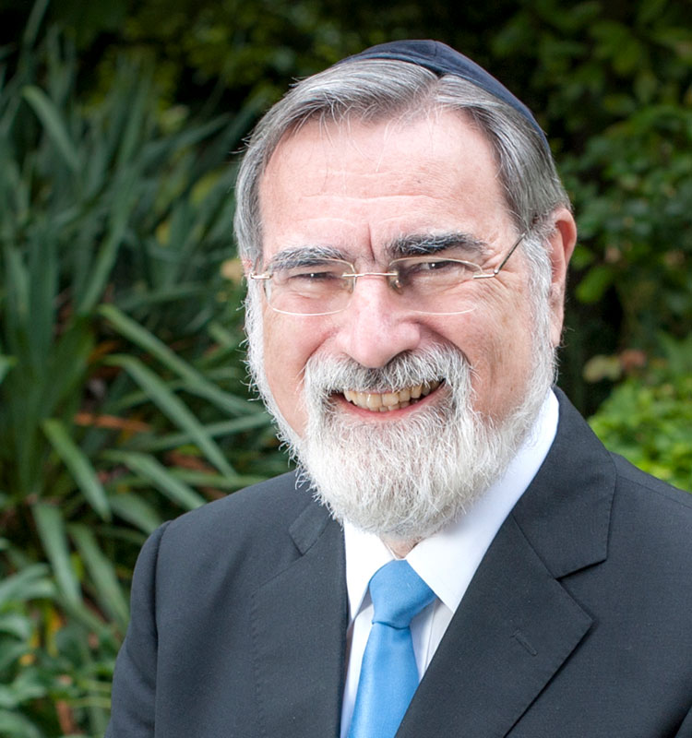
Lord Rabbi Jonathan Sacks

The Chumashim available in shul are different from one another. They have changed and will continue to change. But the next time you walk into shul, you can make an informed choice.
Yosef Lindell is a lawyer, writer and lecturer living in Silver Spring, Maryland. He has written about shul Chumashim for the Forward and Lehrhaus. He has a master’s in Jewish history from Yeshiva University and his essays have appeared in the Atlantic and other popular and scholarly venues.

Reprinted from the Spring 2020 edition of the Jewish Action.

What It’s Like to Be Ireland’s Only Rebbetzin - an Interview with
Chabad Emissary Rifky Lent
By Menachem Posner

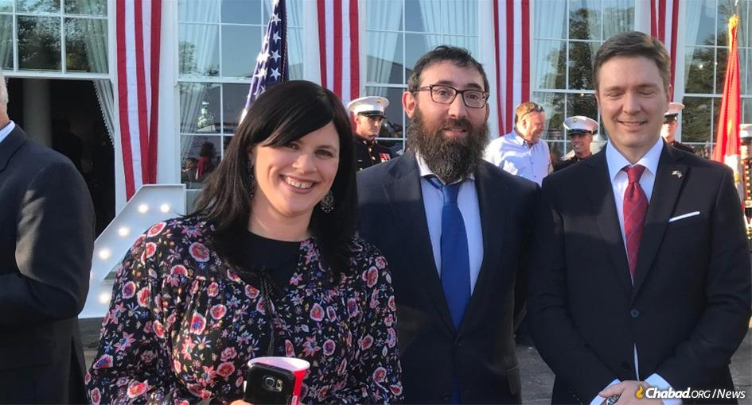
Rifky Lent and Rabbi Zalman Shimon Lent at a Fourth of July celebration at the U.S. embassy in Dublin.

QUESTION: Please tell us about yourself and how you ended up in Ireland.
ANSWER: My husband, Rabbi Zalman Shimon Lent, and I first came to Ireland 20 years ago. He is from Manchester, and I am from London. We were recently married and living in New York when the Jewish community here in Dublin asked Rabbi Moshe Kotlarsky, vice chairman of Merkos L’Inyonei Chinuch—the educational arm of the Chabad-Lubavitch movement—to help them find a suitable youth rabbi. We were both from the United Kingdom, so Ireland is not that far, and I really didn’t want to live somewhere where they didn’t speak English, so we thought we would be a good fit.
Twenty years later, and we’ve become woven into the fabric of Jewish life here. My husband is the rabbi of the main synagogue and the acting chief rabbi of the entire country, and I have the distinction of being the only rebbetzin on the Emerald Isle.
Q: Can you describe the Jewish community in Ireland?
A: There has never been a large Jewish presence here—perhaps 5,000 souls at its peak. There have been Jews here for hundreds of years, originally Sephardim, followed by German Jews, and finally followed by a wave of Eastern European Jews, mostly from Lithuania.
The descendants of the Lithuanian Jews form the base of the established Jewish community here today. Most of them are older. Many children have either moved out of the country or assimilated to one degree or another. And then, we have all kinds of people who come here for work, particularly in the high-tech industry—Israelis, English, Americans, Europeans.

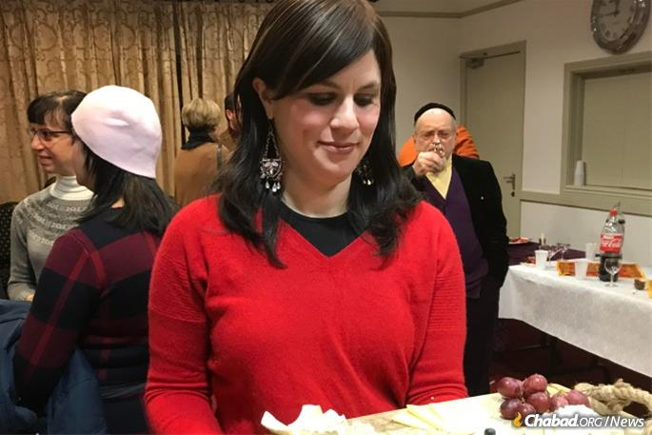
Many in Ireland’s close-knit Jewish community are part of the Lents’ congregation.

The primary Jewish community is here in the capital of Dublin, with tiny communities in other cities like Cork, Limerick and Waterford, which once had functioning congregations but have been reduced to just a handful of individuals.
We live right next door to our synagogue, which is located in a middle-class suburban area, where many other Jews live.
Q: What sort of amenities are there?
A: Many products in Irish supermarkets are sourced from the U.K., so there is a fair amount of kosher available here. There is a shop here in Dublin that carries a full line of kosher cheeses, meats and other products. We have a kosher bakery, which my husband supervises, and that’s pretty much it. There is also a kosher caterer, and my husband supervises a bread factory.

With one of her daughters outdoors on the Emerald Isle

He is the rabbi of the large synagogue, which is similar to the United Synagogues in England. There are, thank G-d, daily services, with a bigger crowd coming for Shabbat and holidays.
Q: Is there a mikvah?
A: When we originally came, the community funded our position from the proceeds of the sale of a beautiful old synagogue in the center of the city that was no longer needed. There had been a mikvah in that synagogue, built through the efforts of the Chabad shochatim who lived here shortly after the Second World War. When that facility was sold, the community was reluctant to build a new one since there was little demand, and they figured that it would be cheaper for them to pay for the women to fly to England whenever they needed the mikvah. The rabbi at the time insisted that they build a new one near the remaining synagogue, where we serve. A few years ago, it was beautifully renovated. Thank G-d, there are several women who use it on a regular basis.

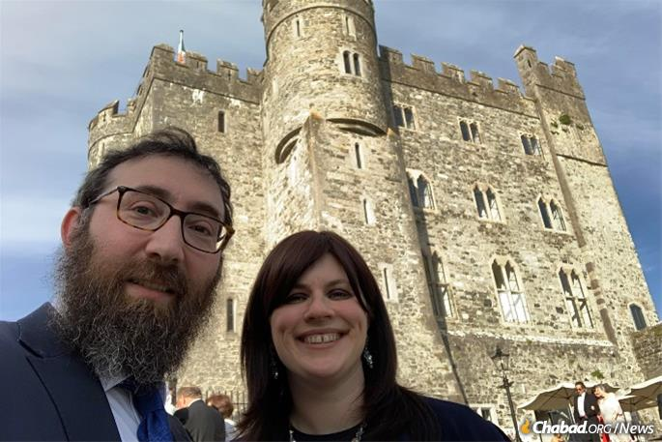
Ireland has a rich history, including a Jewish one.

Q: You mention Chabad shochatim living in Ireland. Can you tell me more?
A: After the Holocaust, Ireland agreed to supply kosher meat to the Jews living in displaced persons (DP) camps in Europe, but they needed shochatim (trained kosher slaughterers). A group of Chabad families relocated to Ireland to fill that need.
Until this very day, there are a handful of middle-aged Chabad men and women in Brooklyn and elsewhere who were born in Ireland. Rabbi Zalman Shimon Dworkin, who later became the leading halachic authority of the international Chabad community, was here, too. In the Jewish Museum here, you can see a meat can with his kosher supervision. It just so happens that my husband is also called Zalman Shimon, so he is the second Chabad rabbi in Ireland with that name!
Q: How old are your children, and what do they do for schooling?
A: Thank G-d, we have a range. Our oldest is a girl, who is now in New York in seminary, and our youngest is a boy, who is home with us. We have a small Jewish day school, where I used to teach and my husband still teaches. Our kids go there until age 11 or so, at which point we send them to board with family in England and attend schools with a more robust Judaic program.

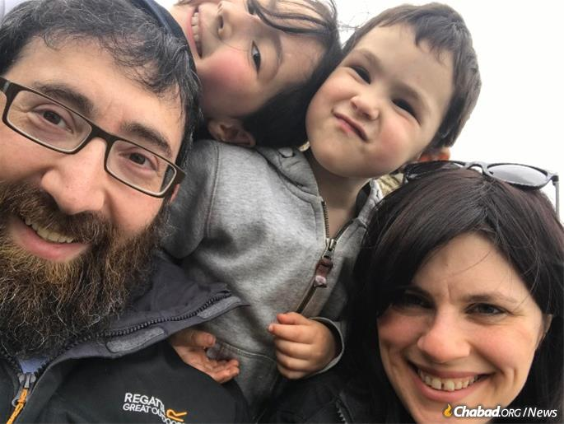
The younger Lent children are educated in the local Jewish day school.

Q: You knew this was coming at some point: How is the mood there, and how are things affected by Brexit?
A: In case your readers do not know, Ireland is not part of the United Kingdom, but we do share a border with Northern Ireland, which is. There is reason to believe that Brexit will attract people to Ireland, which will then be the only English-speaking country in the European Union. But I guess we will need to wait and see. Brexit may also negatively impact us in terms of being able to get kosher food easily.

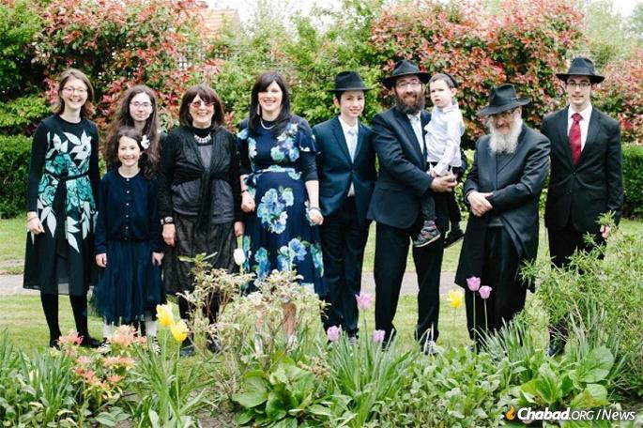
The Lent family at the bar mitzvah of one of their sons, together with Mrs. Lent's parents, Drs. Tali and Kate Miriam Loewenthal.

We are also carefully watching our own parliamentary elections where the Sinn Féin, which is associated with the IRA and extremely anti-Israel, just won the plurality of the votes. It is doubtful that they will form a government, but we are certainly monitoring it.
Q: Is anti-Semitism an issue in Ireland?
A: Having battled against the U.K. for a long time as an underdog that has resorted to terror to accomplish their goals, many Irish people strongly identify with the Palestinians, and there is a strong anti-Israel sentiment. However, there is very little anti-Semitism here, and I feel more safe here than I do when visiting New York.
Q: Are you in New York often?
A: Living in a relatively small Jewish community, I find it immensely rejuvenating to attend the annual conference of Chabad-Lubavitch Women Emissaries, which meets in Brooklyn on an annual basis. It’s an opportunity to talk to people who share my experiences, my goals and my sources of inspiration.
Q: Do you feel lonely in Ireland?
A: We have a lovely community, and we are surrounded by great friends. Yet it is true that there are not many women here who share my background. When we first came, we had dial-up email and phone calls to England were already quite affordable. Thank G-d, with WhatsApp and everything else, it’s very easy to keep in touch with our families, which have spread out across the globe. We are also not too far from the U.K., so it’s not difficult or expensive to fly over for the day and visit family.
Q: After 20 years on the job, what inspires you?
A: The people inspire me. When someone drops me a note or tells me—sometimes, years later—how something I did or said impacted them, that makes everything I do more meaningful and rewarding.
For example, a friend of mine was sitting shiva, and I brought over food so she and her extended family could have a Friday-night meal together, which they did. She later told me that they enjoyed the Shabbat meal so much that they decided to do it again regularly.
We see people coming closer, learning more and inspiring others. And what could be more inspiring than that?

Reprinted from the March 15, 2020 dispatch of Chabad.Org

